**Appendix S2: Examples of analyses on real datasets with R code from package c*limwin***

In this Appendix we detail the R code used to obtain the figures shown in the main text, as well as produce some additional results (weighted means, relative time windows) and provide more details about the features of *climwin*. The examples are based on two datasets that are available as part of package *climwin*:

1. Dataset on British Chaffinches that contains the mean annual egg laying date for the period 1966-2012 (dataset Chaff; Baillie et al. 2014) and daily temperature and rainfall data from the same period from the Central England Temperature dataset (dataset ChaffClim; source Parker, Legg & Folland 1992).
2. Dataset on Australian red-winged fairy wrens that contain the body mass and tarsus length of a thousand individual chicks measured over the breeding seasons of 2008-2014 (dataset Size; source Brouwer, van de Pol & Cockburn 2014) and the daily temperature and rainfall data averaged over the nearest two weather stations (dataset SizeClimate, Manjimup & Pemberton, [www.bom.gov.au/climate/data/](http://www.bom.gov.au/climate/data/)).

**Worked example 1: Weather effects on annual mean laying data of Chaffinch**

We first make sure that the R package *climwin* is installed and loaded:

> install.packages("climwin")

The latest development version containing new features can be installed by:

> devtools::install_github("LiamDBailey/climwin")

> library(climwin)

We then load the weather dataset and the biological dataset containing the egg laying dates:

> Clim <- data(ChaffClim)

> Biol <- data(Chaff)

We can look at both dataset:

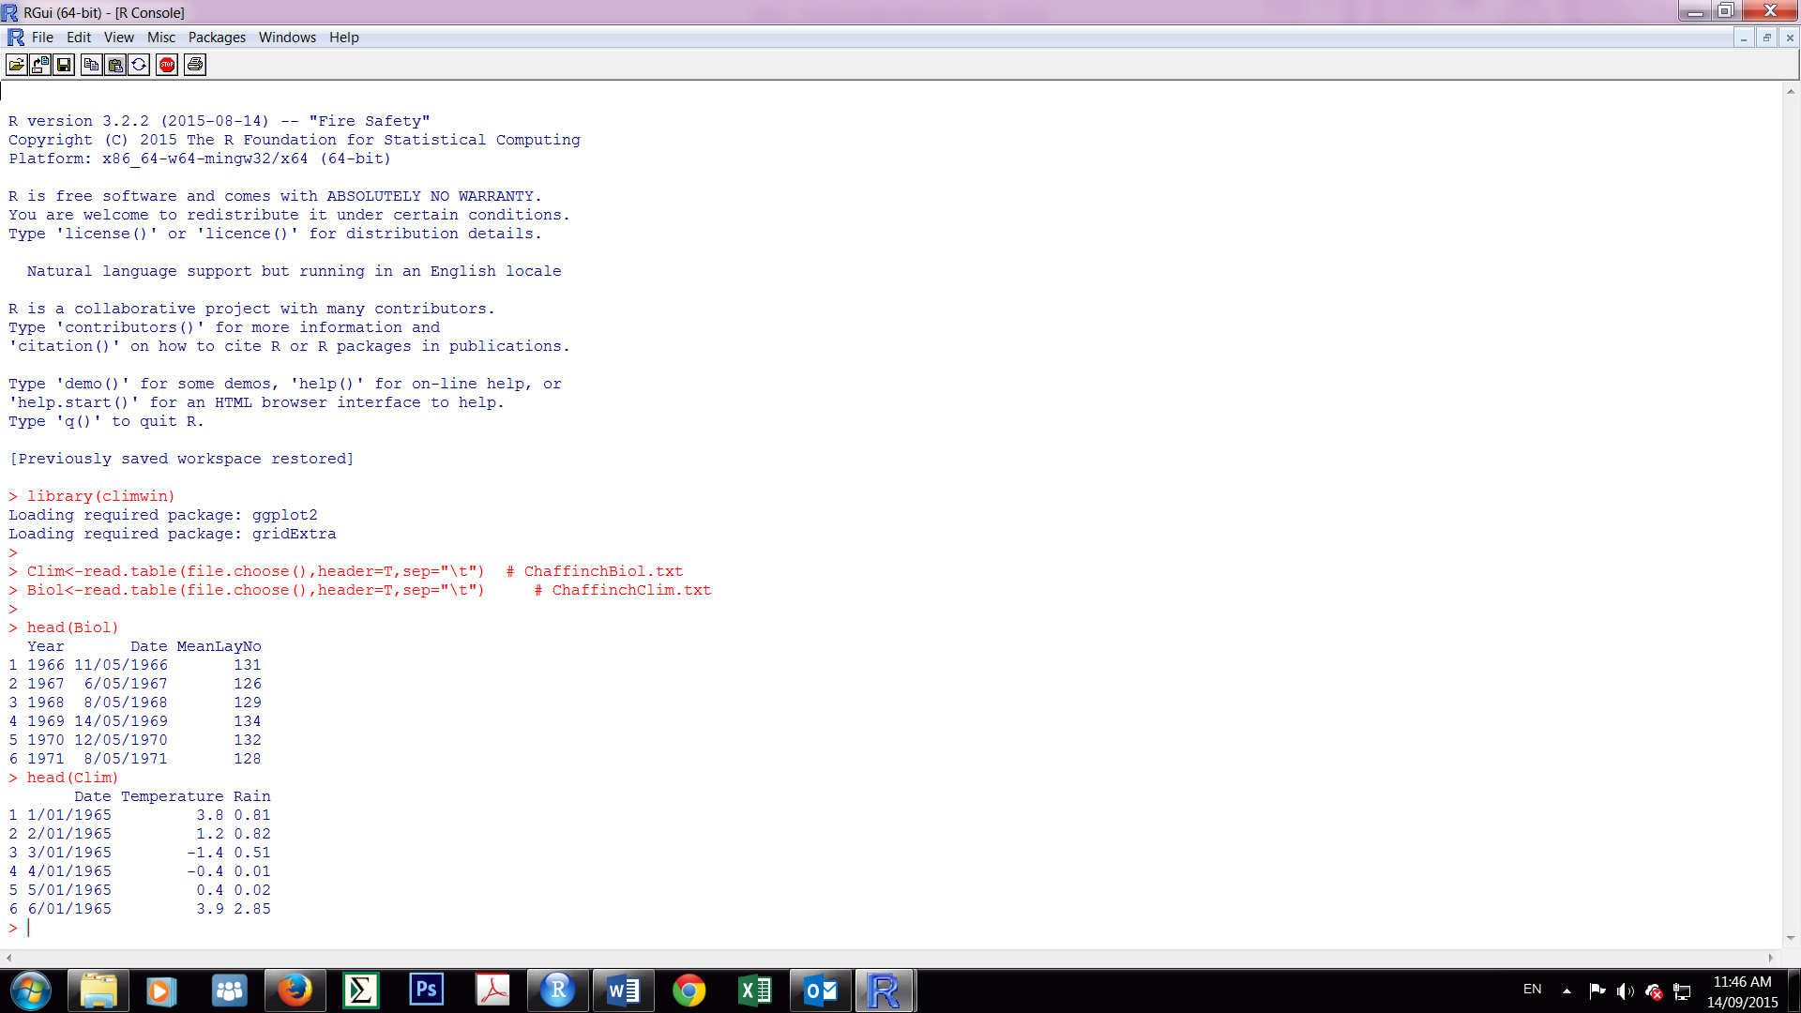

*climwin* assumes that the weather and biological data should be in two separate files. Both files should contain a column with dates (format DD/MM/YYYY) allowing c*limwin* to link the two dataset. The weather data ideally has no missing data and daily values for the entire year, although c*limwin* can also handle weekly or monthly weather data (see documentation ?slidingwin under argument cinterval). The date column in the biological data should reflect the date of measurement. In the case of laying dates, a phenological trait, the date can for example equal the mean laying date (i.e. MeanLayNo), but in other datasets, for example in body mass it could be the day body mass was measured (c*limwin* handles leapdays automatically).

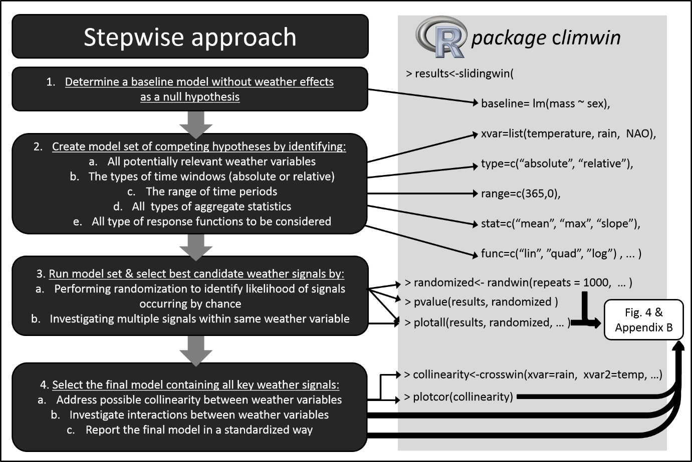

*Step 1*

In the first step of our approach (scheme above and Fig. 3 main text) we determine a baseline model without a climate signal. Chaffinches annual mean laying dates are approximately normally distributed, so for reasons of simplicity we here use a simple linear model, such as lm(Laydate ~ 1, data = Biol). We note that in principle any other type of regression models is possible as long as it can return a loglikelihood or AIC value, however at the moment we have only tested lm, glm, lmer, glmer & coxph. Also one could add confounding non-climatic variables as continuous covariates, categorical factors, or random effects to the baseline model for example lm(Laydate ~1+factor(disturbance),data=Biol), when some years there was a disturbance.

*Step 2*

In the second step we consider the biological hypotheses we would like to test. First, we need to decide which weather variables to focus on. In the Chaffinch example, we focus on temperature and rainfall. We assume that all Chaffinch individuals share the same weather window, therefore we consider only absolute windows (see later section for an example using relative windows). Unless we have strong biological reasoning to constrain our weather window analysis, we encourage users to consider a wide range of windows (e.g. up to one year ago). Since we have daily weather data in this example we consider all time windows up to 365 days in the past. Previous studies on weather sensitivities on other woodland birds have suggested that mean temperature or rainfall is the most important climatic driver, although it has also been suggested that the rate of temperature increase over the season (temperature slope) or a cumulative measure of temperatures above a certain threshold (sensu degree days model) can be important (Crick & Sparks 1999; Schaper *et al.* 2012). Therefore, we test all three of these aggregate statistic hypotheses. Finally, we would like to test the hypothesis that a weather signal can have a nonlinear effect on Chaffinch laying date and therefore consider both linear and quadratic response curves.

*Step 3*

In the third step we use R package *climwin* to translate all the above biological hypotheses into a set of statistical regression models:

> results <- slidingwin( baseline = lm(Laydate ~ 1, data = Biol),

+ xvar =list(Temp=Clim$Temp, Rain=Clim$Rain),

+ type = "absolute",

+ range = c(365, 0),

+ stat = c("mean","slope"),

+ func = c("lin","quad"),

+ refday = c(30, 6),

+ cinterval = "day",

+ cdate = Clim$Date, bdate = Biol$Date)

On the first line we see our baseline model (Step 1) and in the next five R code lines we see the biological hypotheses from Step 2a-e we would like to test: a list of weather variables, the type of window used (absolute), the range of time windows to be considered (0-365 days ago), the aggregate statistics (mean and slope), and the type of response function (linear and quadratic). When using absolute windows one is asked to provide a refday. The easiest choice of refday is the last day any individual was measured or a trait was expressed (30th June in the case of the Chaffinch dataset, coded as refday=c(30,6). These two parameters allow the climate function to decide which data belongs to the same measurement period (e.g. in the southern hemisphere the timing of egg laying may span across a calendar year, e.g. from November-January). The variable cinterval specifies whether climate data is available on a daily, weekly or monthly basis. Finally, we provide the variable names containing the data on the dates of the weather (cdate) and biological dates (bdate). For more details and further arguments, see the documentation of the R package (Bailey & van de Pol 2015).

After executing the R command we can see an overview of the model set and the different combinations of choices made in Step 2a-e. A progress bar will appear as each combination is tested.

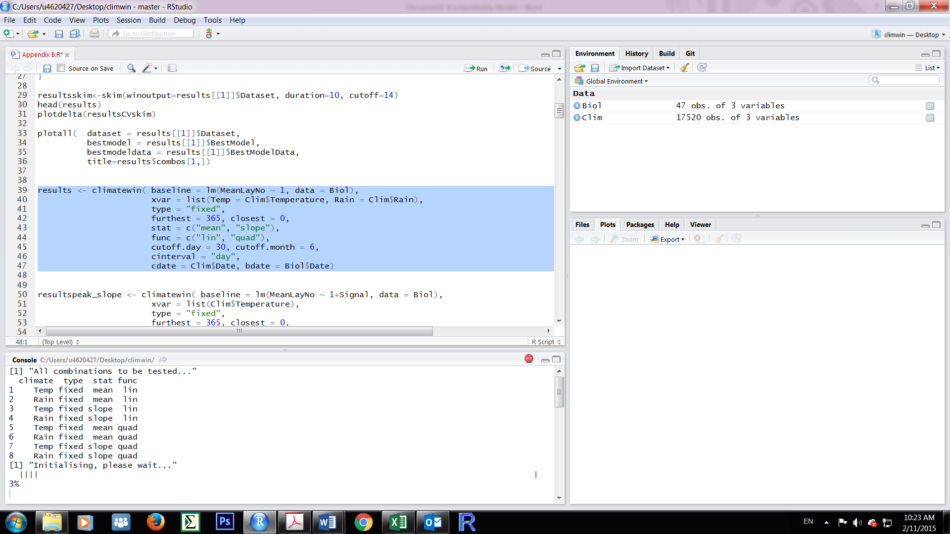 14%

Once the function is finished all model details will be stored in a list, here called ‘results’ Note: Due to the exploratory nature of the *climwin* methodology it can take some time to run all analyses. In particular, models with the aggregate statistic slope are often computationally intensive. Consider removing the state = "slope" argument or reduce the range to range=c(200,0) in order to save time in this worked example,.

Once we have fitted our first set of models we can next consider the degree days model set using temperature only. Here we use a degree day model in which we sum all temperature above 10°C, set by the argument upper in combination with stat:

> results2 <- slidingwin(baseline = lm(Laydate ~ 1, data = Biol),

+ xvar = list(Temp = Clim$Temp),

+ type = "absolute",

+ range = c(365, 0),

+ stat = c("sum"), upper=c(10),

+ func = c("lin","quad"),

+ refday = c(30, 6),

+ cinterval = "day",

+ cdate = Clim$Date, bdate = Biol$Date)

[1] "All combinations to be tested..."

climate type stat func upper lower binary

1 Temp absolute sum lin 10 NA FALSE

2 Temp absolute sum quad 10 NA FALSE

Subsequently, after the model is finished running we can merge both outputs into one object:

> output <- merge_results(results,results2)

The output of slidingwin consists of four parts:

> output$combos

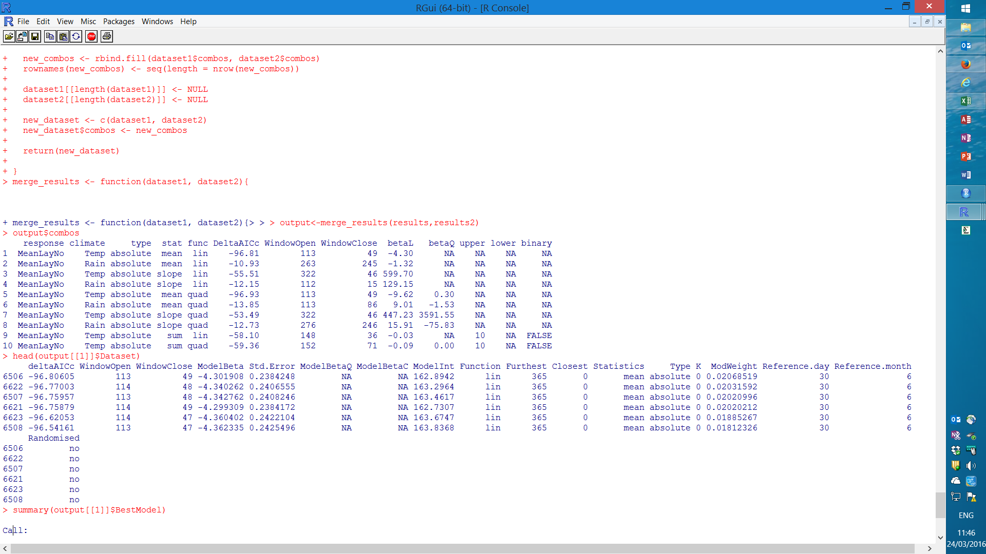

provides a summary of all tested climate window hypotheses, with the key statistics from the best model included; the ∆AICc of the best model, the timing of the best climate window (open and close) and the associated beta-estimate(s) of the effect of of the climate signal on egg laying date (note that for reasons of clarity we have not shown all columns from output$combos). A subset of these results were used to create Table 1 of the main text. The combos-list is also relevant for other purposes, as the first column provides the reference number for each combination (here 1-10), which is needed to inspect the more detailed parts of the output.

If we want to investigate one of our hypotheses further we can look at the full dataset of all fitted climate windows. In this case, we are interested in the linear impact of mean temperature (list item 1), which we can access using the following code:

> head(output[[1]]$Dataset)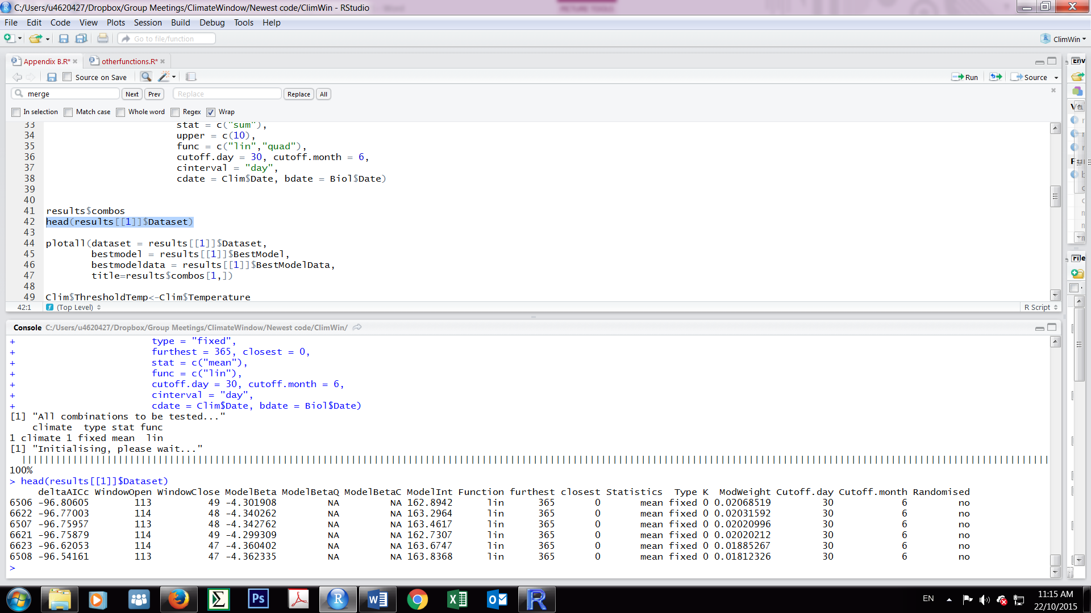

Note that in this list the models are sorted by ∆AICc, such that the best supported model is on top. To investigate any other tested hypothesis we can simply replace the number in the double square brackets with the corresponding list number from results$combos. For example, to look at the quadratic effect of mean rainfall (list item 6) we can run the code head(output[[6]]$Dataset).

The third part of the output provides the results from the best supported model for each hypothesis. Note that, once again, we use the square brackets with the corresponding number from results$combos:

> summary(output[[1]]$BestModel)

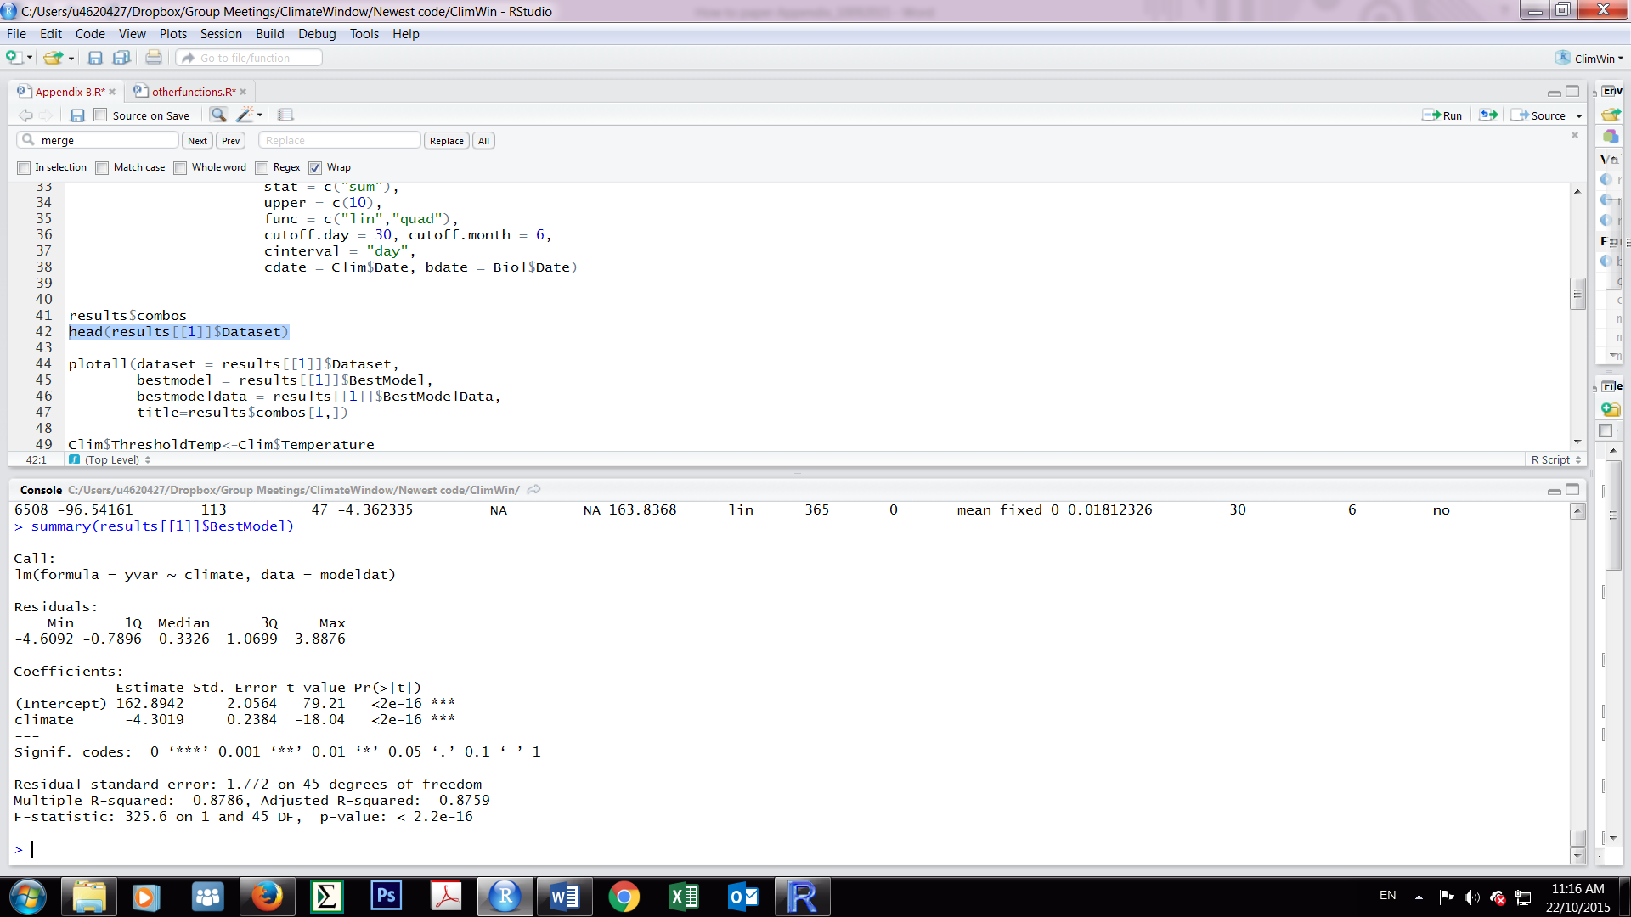

Finally, the object BestModelData stores the values of the climate signal that was best supported by the data and the row numbers correspond to the original row numbers of the Biol dataset.

head(output[[1]]$BestModelData)

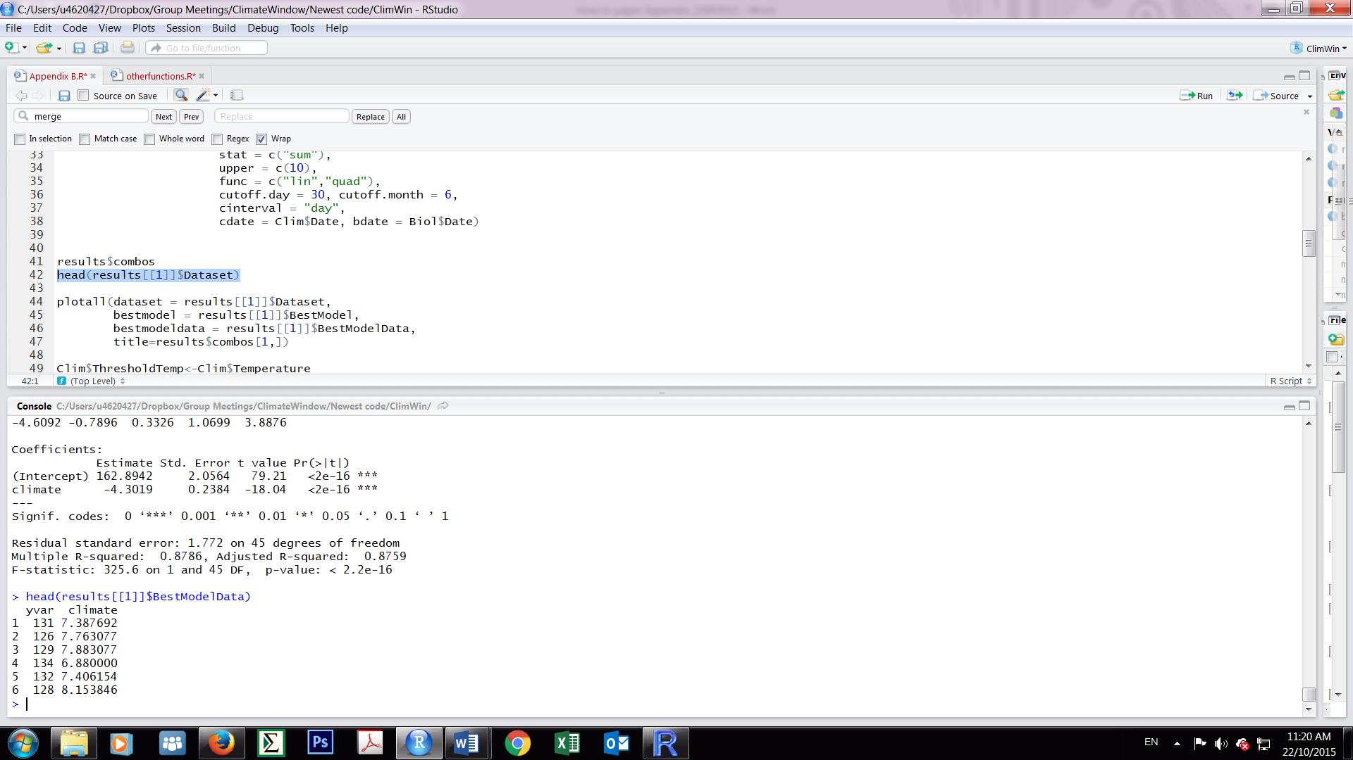

The best supported climate variable can be attached to the original dataset for further analyses:

Biol$signal <- output[[1]]$BestModelData$climate

Before doing further visual inspection of the key output, we first perform some randomization as part of step 3a. The exploratory nature of *climwin* makes it possible that some candidate signals may occur simply by chance due to the fact that so many possible climate windows are tried. For example, when looking back 365 days, the number time windows tested is 66,795 (i.e. *m*(*m*+1)/2, with *m* being the maximum number of intervals, 365 here). Randomization via the function randwin is a necessary step to determine the likelihood of a climate signal occurring by chance. This function randomizes the bdate column in the original biological dataframe Biol, thereby retaining the original data structure (including other variables in the baseline model) and temperature structure, but removing any climate signal. The function randwin has a similar syntax as slidingwin, with the addition of the argument repeats which determines how many times one would like to randomize the data and run the model set on it. Ideally one does thousands of randomizations, but a practical constraint is that this can take very long (see main text and Appendix S3 for alternative methods *PC*), here we just run it 10 times to show the basic idea.

> randomized1<-randwin(repeats = 10,

+ baseline = lm(Laydate ~ 1, data = Biol),

+ xvar = list(Clim$Temp),

+ type = "absolute",

+ range = c(365, 0),

+ stat = c("mean"),

+ func = c("lin"),

+ refday=c(30, 6),

+ cinterval = "day",

+ cdate = Clim$Date, bdate = Biol$Date,

+ window= "sliding")

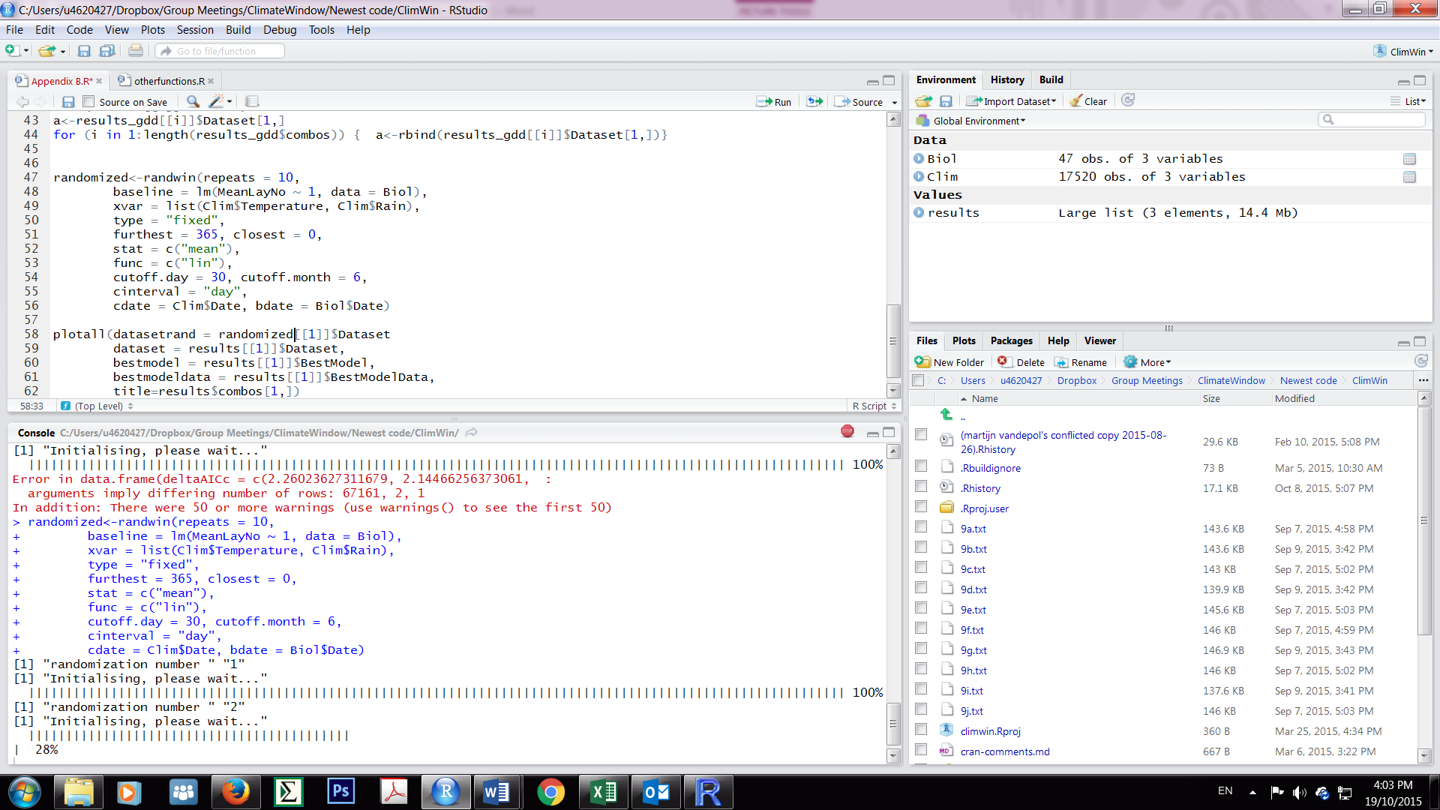

We can then calculate the P-value using two different methods. When many randomizations have been done (~100-1,000) one can use P∆AICc:

>pvalue(datasetrand = randomized1[[1]], dataset = output[[1]]$Dataset, metric = "AIC", sample.size = 47)

≤0.1

If this is too time-consuming, then one can run 5-10 randomizations and calculate PC instead (see Appendix S3 for details):

> pvalue(datasetrand = randomized1[[1]], dataset = output[[1]]$Dataset, metric = "C", sample.size = 47)

0.0298

The next part of Step 3 involves identifying candidate climate signals for each hypothesis, and c*limwin* provides various tools for visual inspection and interpretation of the results, most notably the plotall function:

> plotall(datasetrand = randomized1[[1]],

+ dataset = output[[1]]$Dataset,

+ bestmodel = output[[1]]$BestModel,

+ bestmodeldata = output[[1]]$BestModelData,

+ title=output$combos[1,])

It outputs several panels that visually describe the key outcomes for the combination [[1]], which are the models assuming a linear effect of mean temperature. We first discuss the four panels that were also shown in Figure 4 in the main text:

1. 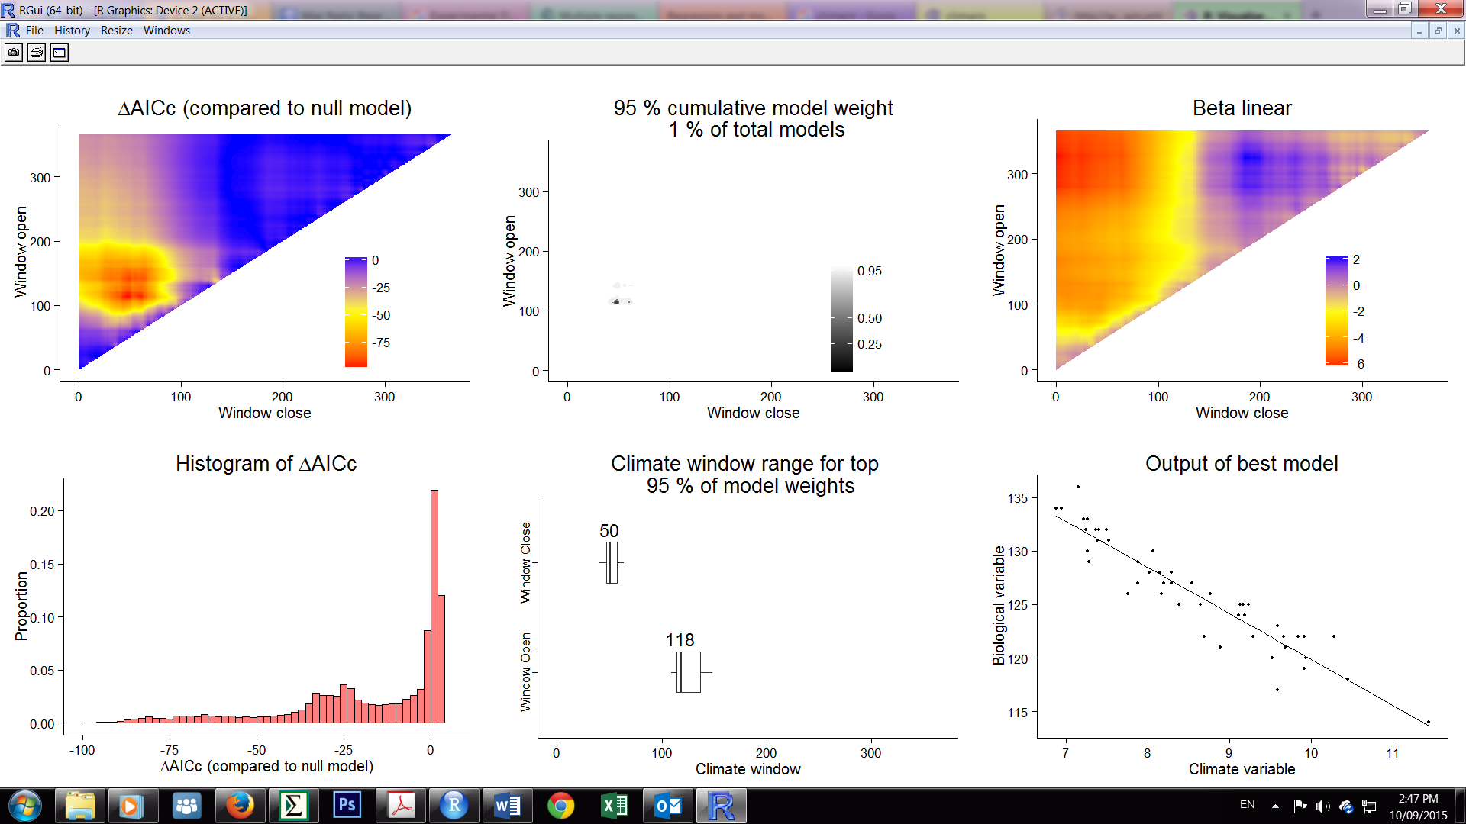This panel shows the model support (∆AICc) for all fitted time windows tried, shown for each combination of Window open (y-axis) and Window close (x-axis). Models with the lowest ∆AICc (red) are the best supported (colours show the ∆AICc levels compared to the null model, see legend). Strongly supported windows will often be grouped together. The single best supported window can be found using results[[1]]$Dataset[1,].



1. This panel shows the relationship between the climate signal from the single best supported time window (here mean temperature between day 49-113 [12 May - 9 March] and the biological response (here laying date). The response variable laying date is corrected for other confounding variables in the baseline model (by mean centring covariate and taking the reference category for factors). The exact slope estimate is found using output[[1]]$Dataset[1,].
2. While we are often interested in estimating the slope of the best climate window, we may also be interested in understanding the relationship between climate and our biological response in other nearby windows to understand how sensitive the result is to the exact choice of best time window. This panel shows the spread of model coefficients across all fitted climate windows (with colours showing the linear slope values, see legend). In the plot, we can see that windows around our best model (see dashed circle) all show a negative relationship between temperature and laying date while models with windows closing more than 200 says ago showing little relationship (slope close to zero).



1. 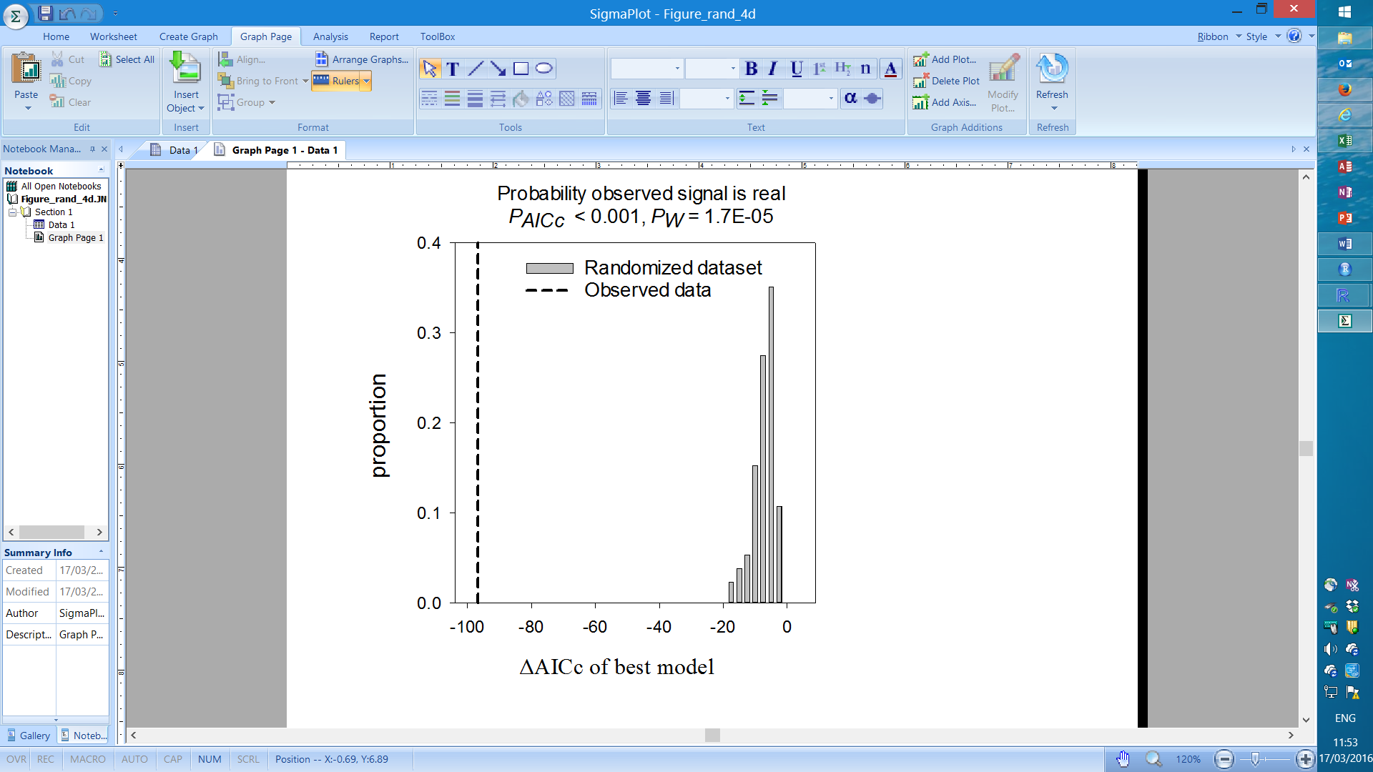An important question is: How do we know whether the best model is any good? Or phrased differently: how likely is it that one obtains such a low ∆AICc by chance if one runs so many models? The large number of models that are being fitted on the actual data prevent us from using conventional rules of thumb for model selection based on ∆AICc, such as a ∆AICc=-5 being strong support for a model. This panel therefore shows a histogram of all ∆AICc values from all models run on the randomized (in grey) and the ∆AICc of the best model fitted on the observed data (dashed line). The best climate window in the randomized data is by definition a false positive, as the randomization procedure removes any climate signal from the data. The percentage of randomizations that generates a ∆AICc value that is at least as low as the ∆AICc value of the best model fitted to the observed data (called statistic P∆AICc) is a measure of how likely it is that one obtained the observed ∆AICc by chance and thus whether the signal is likely to be real or not. In our Chaffinch example, the best model has a ∆AICc=-97, substantially higher than the best model in all the 1,000 randomized Chaffinch data (ΔAICc=-19). In this case we can say that the candidate signal of mean temperature is very unlikely to be a false positive: P∆AICc <0.001. By contrast, if we would also perform randomization for the models that assume a linear effect of mean rainfall (note that to save time we only run 10 repeats again here):

> randomized2<-randwin(repeats = 10,

+ baseline = lm(Laydate ~ 1, data = Biol),

+ xvar = list(Clim$Rain),

+ type = "absolute",

+ range = c(365, 0),

+ stat = c("mean"),

+ func = c("lin"),

+ refday=c(30, 6),

+ cinterval = "day",

+ cdate = Clim$Date, bdate = Biol$Date,

+ window = "sliding")

Obtain the PC-value:

> pvalue(datasetrand = randomized2[[1]], dataset = output[[2]]$Dataset,

metric="C", sample.size=47)

0.1034

And then visually inspect the output of the models for linear effect of mean rainfall:

> plotall(datasetrand = randomized2[[1]],

+ dataset = output[[2]]$Dataset,

+ bestmodel = output[[2]]$BestModel,

+ bestmodeldata = output[[2]]$BestModelData,

+ title=output$combos[2,])

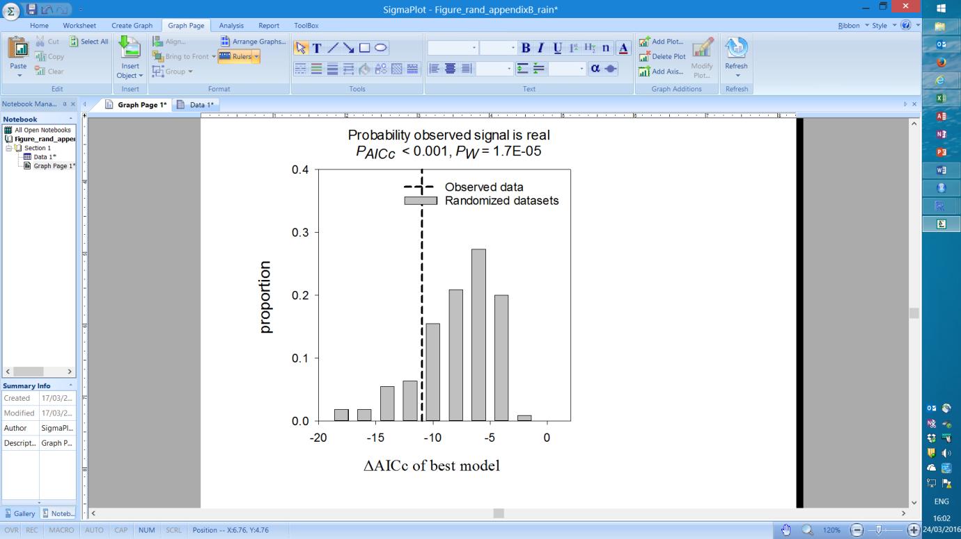This shows that the observed ΔAICc lies within the randomized distributions, and in such situation it seems much less likely that the best mean rainfall time window is a false positive and should possibly not be considered further (i.e. P∆AICc=0.21). It also highlights that by chance even some of the many models fitted using the randomization method can achieve ΔAICc scores that would be considered evidence for strong model support by conventional standards (ΔAICc<-5; Burnham & Anderson 2002). The same holds for p-values of the beta-estimates in the randomized data of which many are highly significant (e.g. the best model on randomized data had a climate signal slope coefficient with p<0.001; see summary(output[[2]]$BestModel), and thus should not be used for model selection in the conventional way.

The plotall function produces two more panels that can be used for further visual inspection.

1. Another way to visualise the model support is through the use of Akaike model weights (Burnham, Anderson & Huyvaert 2011). In short, the higher a model weight value the greater confidence we have that this model is the true ‘best’ model. While our top climate window is the most likely single window to best explain the data, our confidence that this top window represents the true ‘best’ model may still be low. If we sum the weights of multiple models, we can now be more confident that we encompass the true best model, but we are less sure of its exact location. In our model-weights plot we shade all models that make up the top 95% of model weights (i.e. the 95% model confidence set). Therefore, we can be 95% confident that the true ‘best’ model falls within the shaded region (see blue arrow). In our example of a linear effect of mean temperature, we can see that the 95% model confidence set falls within a small region corresponding to the middle of the red peak in ∆AICc seen in panel 1. In fact, we can be 95% sure that the best climate window falls within only 1% of the total fitted models (metric C; Box 2 main text), as stated at the top of the panel.

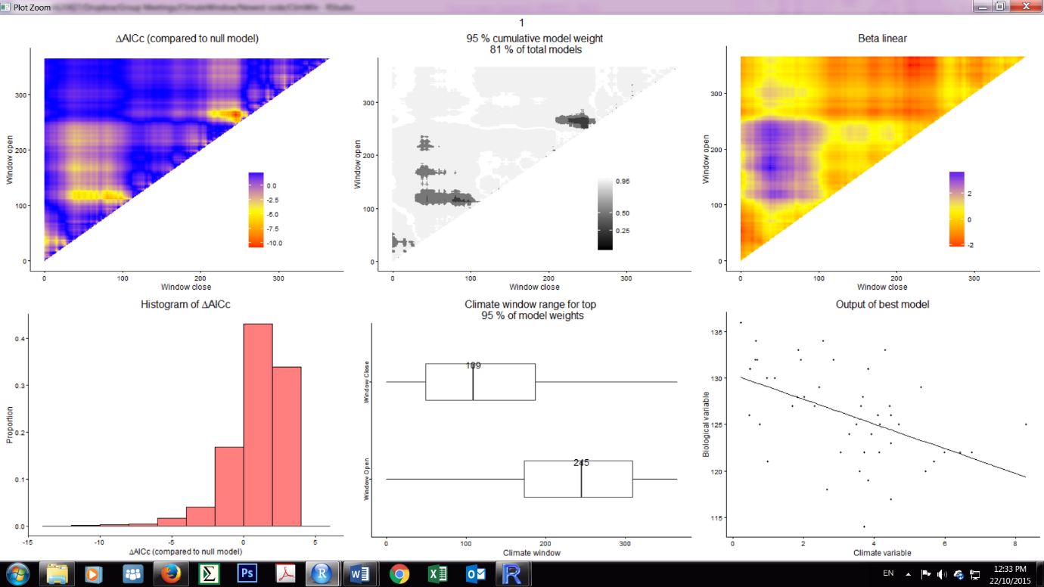If we compare it to the model-weight plot of the linear effect of mean rainfall, we see there is no clear peak of model support, in fact almost all models are roughly equally well supported. In fact, we can be 95% sure that the best climate window falls within 81% of the total fitted models, as stated at the top of the panel. Such a plot where the 95% model confidence set is widely spread is indicative for false-positive signals, which was previously more formally confirmed by the randomization test shown above.

1. Finally, one may not be interested in knowing only the best time window of a linear effect of mean temperature, but of all the best supported models (i.e. multi-model inference). This panel shows the opening and closing points of the time windows that were best supported by the data, here those models that made up 95% model confidence set (the gray shaded models in panel 5).

*Cross-validation*

In the main text we explained that cross-validation can be important to obtain unbiased estimates of R2 for the best climate but this was primarily important in datasets with N≤20. In the Chaffinch dataset we have 47 years, so cross-validation should not be a high priority. However, we could easily perform cross-validation for illustrative purposes using the argument k in slidingwin (see code below). Note that this will take k time as long to run as the previous models.

> outputCV<- slidingwin( k=10,

+ baseline = lm(Laydate ~ 1, data = Biol),

+ xvar = list(Clim$Temp),

+ type = "absolute",

+ range = c(365, 0),

+ stat = c("mean"),

+ func = c("lin"),

+ refday=c(30, 6),

+ cinterval = "day",

+ cdate = Clim$Date, bdate = Biol$Date )

We can compare the model output from the models run with and without cross-validation, showing that outcomes (summarized below) are very similar in this case.

> output$combos[1,]

beta ∆AICc close open

1 4.301 -96.81 49 113

> outputCV$combos[1,]

beta ∆AICc close open

1 4.418 -12.61 44 112

The only exception is the value of ∆AICc, which is generally much lower when using cross- validation, however, as this is also the case for the randomization, this still leads to similar P∆AICc or PC values as for methods without cross-validation (not shown).

One can subsequently perform visual inspection and randomization for all hypotheses listed in output$combos using the techniques discussed above i.e. plotall(output[[2]]$Dataset), etc. Henceforth we focus on the datasets without cross-validation. Visual inspection helps to identify candidate signals for each combination of climate variable (temperature, rain), aggregate statistic (mean, slope), and response type function (linear, quadratic). The summary below suggests that, comparing the ∆AICc of the best supported time windows for both the real and randomized data that there are potential candidate signals for combinations 1, 3, 5, 7, 9 & 10 (highlighted in gray)

climate type stat func upper ∆AICc P∆AICc close open

1 climate 1 absolute mean lin NA -96.81 <0.001 49 113

2 climate 2 absolute mean lin NA -10.93 0.21 245 263

3 climate 1 absolute slope lin NA -55.51 <0.001 46 322

4 climate 2 absolute slope lin NA -12.15 0.14 15 112

5 climate 1 absolute mean quad NA -96.93 <0.001 49 113

6 climate 2 absolute mean quad NA -13.84 0.10 86 113

7 climate 1 absolute slope quad NA -53.48 <0.001 46 322

8 climate 2 absolute slope quad NA -12.73 0.14 246 276

9 climate 1 absolute sum lin 10 -58.09 <0.001 36 148

10 climate 1 absolute sum quad 10 -59.36 <0.001 71 152

Now that we have identified possible candidate signals, we next consider the possibility of multiple peaks for the same climate variable (Step 3b). There may be non-mutually exclusive effects of short-lag (more recent) and long-lag (more distant) climate signals that could be acting at different stages of the study organism’s life cycle (Fig. 2 in main text; van de Pol & Cockburn 2011). For example, high temperatures during winter may have positive effects on reproductive performance, while a recent sequence of several hot days can have negative effects when tolerance thresholds are exceeded (Kruuk, Osmond & Cockburn 2015). Multiple peaks are most easily investigated looking at the ∆AICc landscape of all combos (we focus on the linear response curves here only, as the quadratic response curves are not much better supported than the linear response curves):

> mean_lin<-plotdelta(dataset = output[[1]]$Dataset)

> slope_lin<-plotdelta(dataset = output[[3]]$Dataset)

> sum_lin<-plotdelta(dataset = output[[9]]$Dataset)

> gridExtra::grid.arrange(mean_lin, slope_lin, sum_lin, nrow = 1, ncol = 3)

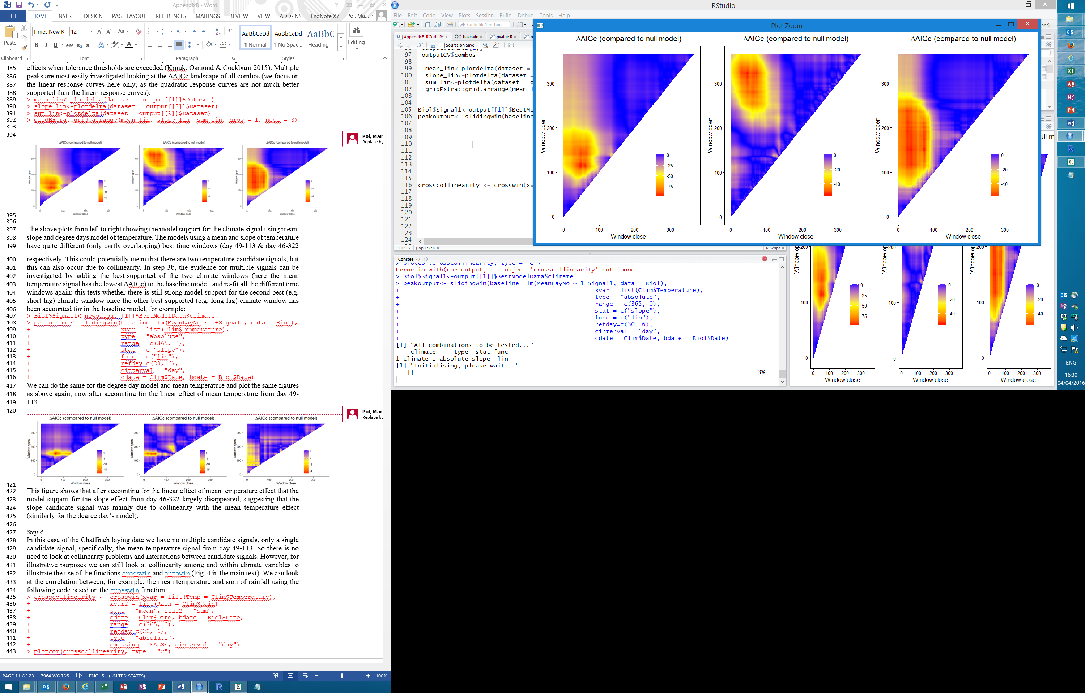

The above plots from left to right showing the model support for the climate signal using mean, slope and degree days model of temperature. The models using a mean and slope of temperature have quite different (only partly overlapping) best time windows (day 49-113 & day 46-322 respectively. This could potentially mean that there are two temperature candidate signals, but this can also occur due to collinearity. In Step 3b, the evidence for multiple signals can be investigated by adding the best-supported of the two climate windows (here the mean temperature signal has the lowest ∆AICc) to the baseline model, and re-fit all the different time windows again: this tests whether there is still strong model support for the second best (e.g. long-lag) climate window once the other best supported (e.g. short-lag) climate window has been accounted for in the baseline model, for example:

> Biol$Signal1<-output[[1]]$BestModelData$climate

> peakoutput<- slidingwin(baseline= lm(Laydate ~ 1 + Signal1, data = Biol),

+ xvar = list(Clim$Temperature),

+ type = "absolute",

+ range = c(365, 0),

+ stat = c("slope"),

+ func = c("lin"),

+ refday=c(30, 6),

+ cinterval = "day",

+ cdate = Clim$Date, bdate = Biol$Date)

We can do the same for the degree day model and plot the same figures as above again, now after accounting for the linear effect of mean temperature from day 49-113.

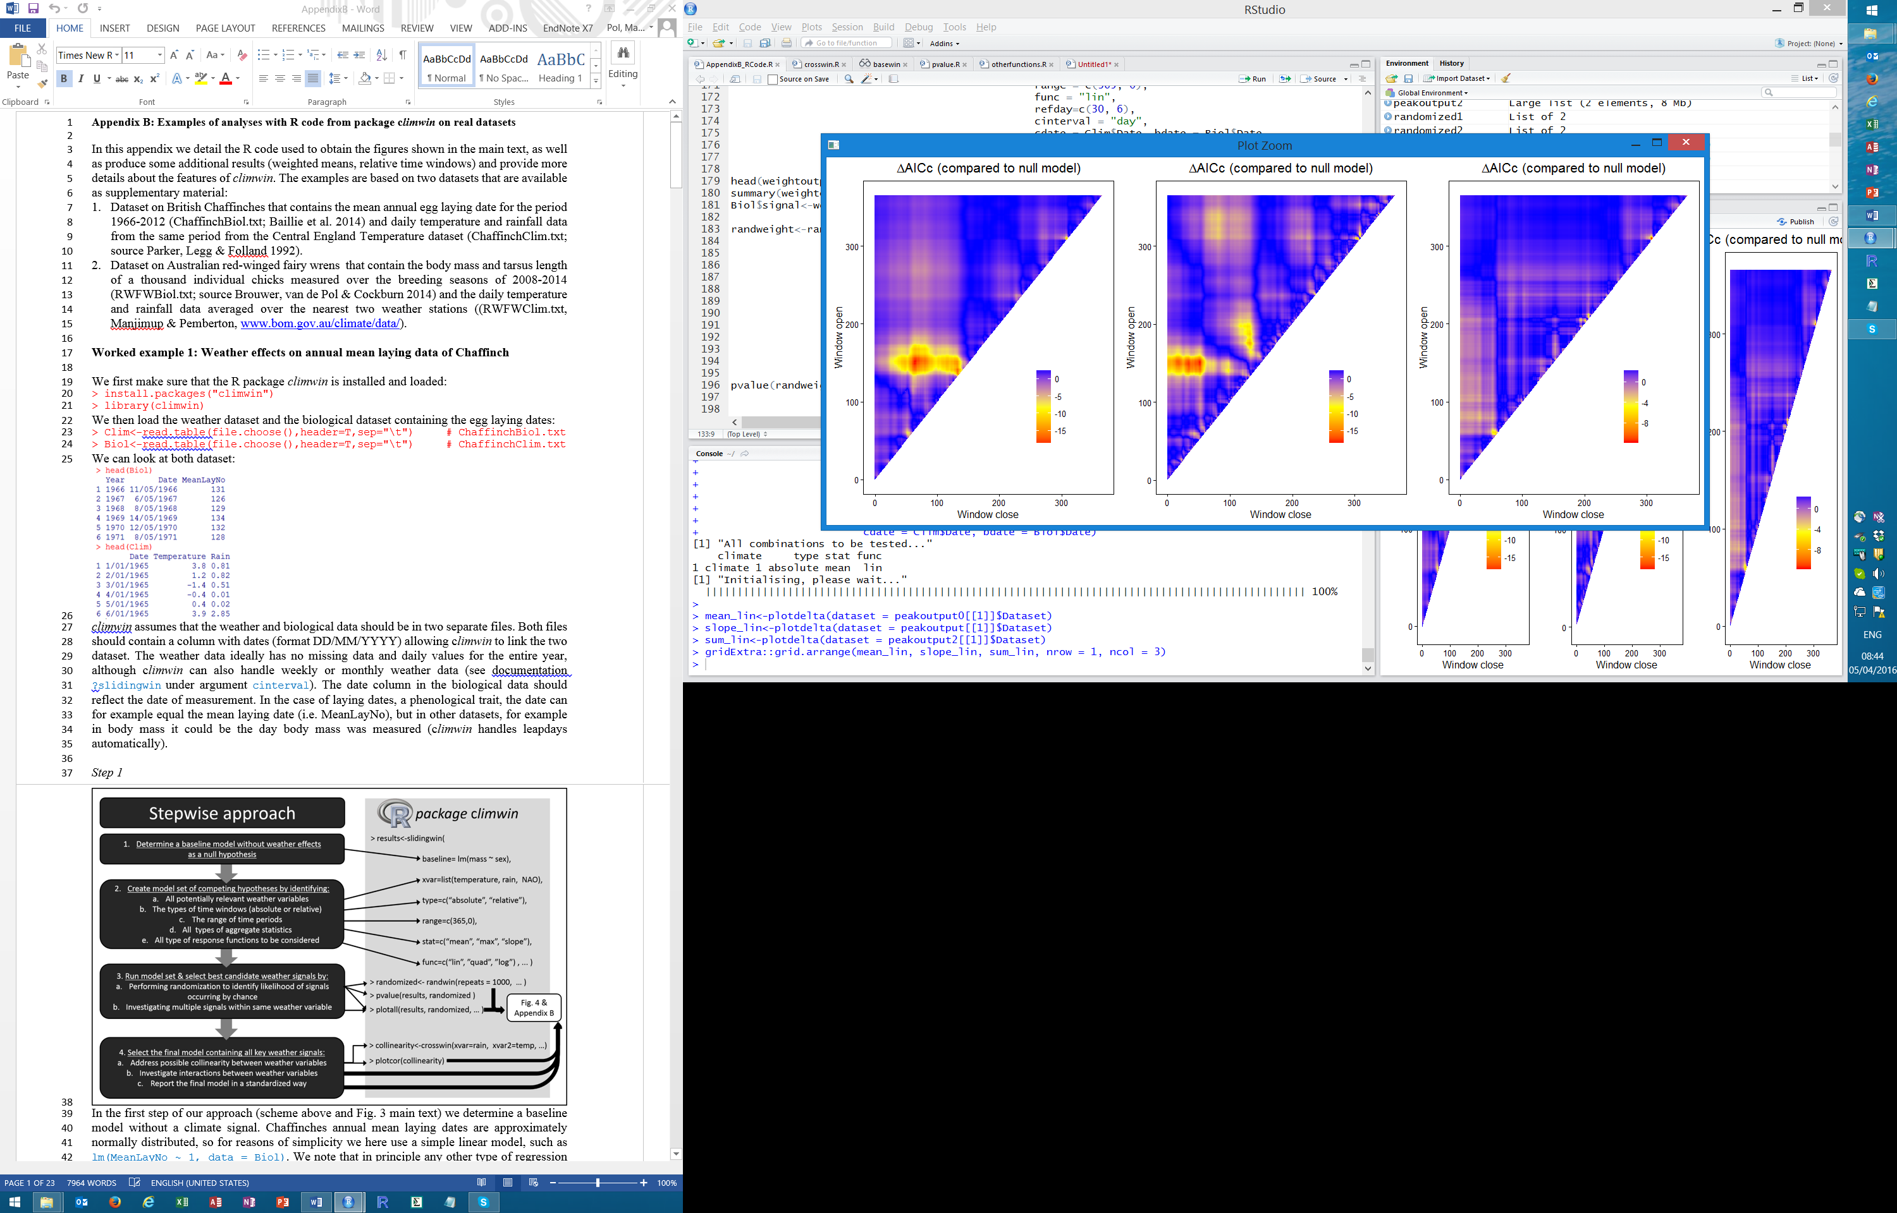

This figure shows that after accounting for the linear effect of mean temperature effect that the model support for the slope effect from day 46-322 largely disappeared, suggesting that the slope candidate signal was mainly due to collinearity with the mean temperature effect (similarly for the degree day’s model).

*Step 4*

In the case of the Chaffinch laying date we have no multiple candidate signals, only a single candidate signal, specifically, the mean temperature signal from day 49-113. So there is no need to look at collinearity problems and interactions between candidate signals. However, for illustrative purposes we can still look at collinearity among and within climate variables to illustrate the use of the functions crosswin and autowin (Fig. 4 in the main text). We can look at the correlation between, for example, the mean temperature and sum of rainfall using the following code based on the crosswin function.

> crosscollinearity <- crosswin(xvar = list(Temp = Clim$Temp),

+ xvar2 = list(Rain = Clim$Rain),

+ stat = "mean", stat2 = "sum",

+ cdate = Clim$Date, bdate = Biol$Date,

+ range = c(365, 0),

+ refday=c(30, 6), cohort=Biol$Year,

+ type = "absolute",

+ cmissing = FALSE, cinterval = "day")

> plotcor(crosscollinearity, type = "C")

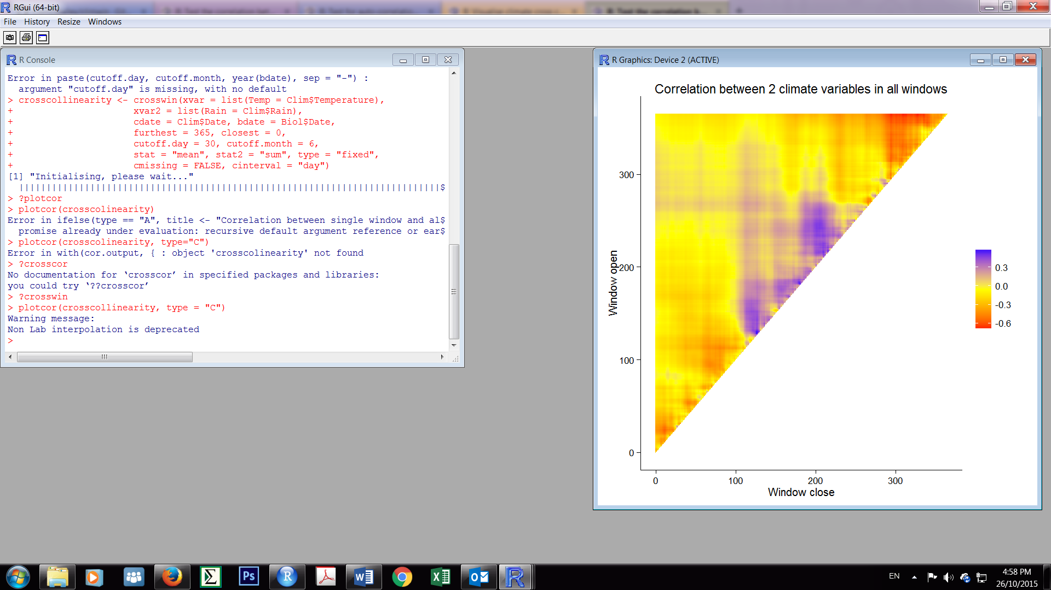

The different colours show the correlation between the mean temperature and rainfall sum over all the different time windows, with yellow colours showing no correlation, red a negative and blue a positive. This illustrates that the correlation between climate variables can be weak in some parts of the year but strong in others, highlighting that dealing with collinearity is most sensible once the critical time windows are known.

One can also look at the correlation between the mean temperature during the best supported time window (day 49-113) and for example the mean temperature (or any other combination of climate variable and aggregate statistic, see arguments xvar and stat) over all other time windows using the autowin function:

> autocollinearity<-autowin(reference = results[[1]],

+ xvar = list(Temp = Clim$Temp),

+ cdate = Clim$Date, bdate = Biol$Date,

+ baseline = lm(Laydate ~ 1, data = Biol),

+ range = c(365, 0), cohort=Biol$Year,

+ stat = "mean", func = "lin",

+ type = "absolute",

+ refday=c(30, 6),

+ cmissing = FALSE, cinterval = "day")

> plotcor(autocollinearity, type="A")

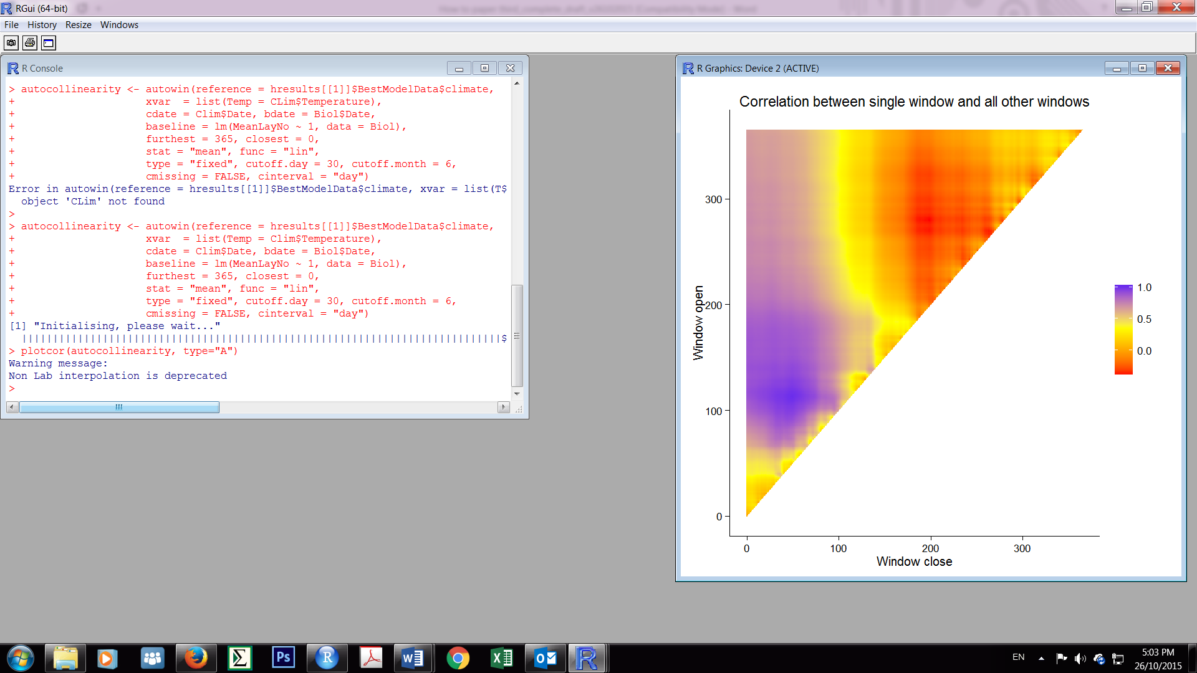

The colours show the strength of correlation between the mean temperature during each time window and the mean temperature during the best supported time window from day 49-113. This figure illustrates that mean temperatures are typically strongly correlated among nearby (partly overlapping) time windows, which explains why a wide range of adjacent time windows can receive high model support (and similar slopes) even if the biological effects of climate only act during a particular one of these windows (see red peak in Fig. 4a main text).

*Reporting model set and final output*

For comparison among studies two things are important. Firstly, it should be clear which model set was considered in each study. Second, the final model should be reported in such a way that the response curve can be reconstructed for use in future analyses and one should include information about variability in both the climate signal and biological response variable, such that standardized effect sizes can easily be calculated for use in meta-analyses.

The model set considered here can be described by the following information, each point describing one of the five decisions from step 2a-e in Figure 3 of the main text:

1. Climate variables: temperature and rainfall
2. Type of window: absolute window with day 0 being 30th June
3. Range of time period: 0-365 days, daily intervals
4. Aggregate statistics: mean, slope, growing degree days model with base temperature of 10°C (note that only the mean and slope models were applied to the rainfall variable)
5. Response functions: linear & quadratic

The final model looks like this:

> summary(output[[1]]$BestModel)

Call:

lm(formula = yvar ~ climate, data = modeldat)

Residuals:

Min 1Q Median 3Q Max

-4.6092 -0.7896 0.3326 1.0699 3.8876

Coefficients:

Estimate Std. Error t value Pr(>|t|)

(Intercept) 162.8942 2.0564 79.21 <2e-16 ***

climate -4.3019 0.2384 -18.04 <2e-16 ***

---

Signif. codes: 0 ‘***’ 0.001 ‘**’ 0.01 ‘*’ 0.05 ‘.’ 0.1 ‘ ’ 1

Residual standard error: 1.772 on 45 degrees of freedom

Multiple R-squared: 0.8786, Adjusted R-squared: 0.8759

F-statistic: 325.6 on 1 and 45 DF, p-value: < 2.2e-16

And assuming we are not so much interested in the P-values and test statistics of the parameter estimates, but most interested in the parameter estimates themselves and their uncertainty, the final model can be summarized by the following information:

Gaussian model with Residual error of 1.78

Model: MeanLayNo = 162.89(±2.06SE) -4.30(± 0.24 SE)*temperature[mean of day 49-133]

For standardization purposes one should also report the variability (e.g. standard deviation) in both the biological response and climate signal:

> sd(output[[1]]$BestModelData$yvar)

[1] 5.029607

> sd(output[[1]]$BestModelData$climate)

[1] 1.095869

Such that we can calculate for example how many standard deviations laying dates change

per degree of temperatures change (.i.e. -4.30/ 5.03= -0.86 SD/°C) or per standard

deviation change in the climate signal.

Finally, one should report the sample size:

> length (output[[1]]$BestModelData$climate)

[1] 47

**Weighted means**

In the Chaffinch data we found that mean temperature was the strongest climate signal. For this analysis we aggregated climate over a certain time window by weighting each day in that window equally (e.g. by calculating the unweighted mean). However, this may often be biologically unrealistic, as more recent weather could have a stronger influence than weather in the more distant past (Gienapp, Hemerik & Visser 2005; van de Pol, Osmond & Cockburn 2012). Weighted means can account for such gradual decay effects and also do not have the abrupt change in influence that normal (unweighted) means have at the beginning and end of the window.

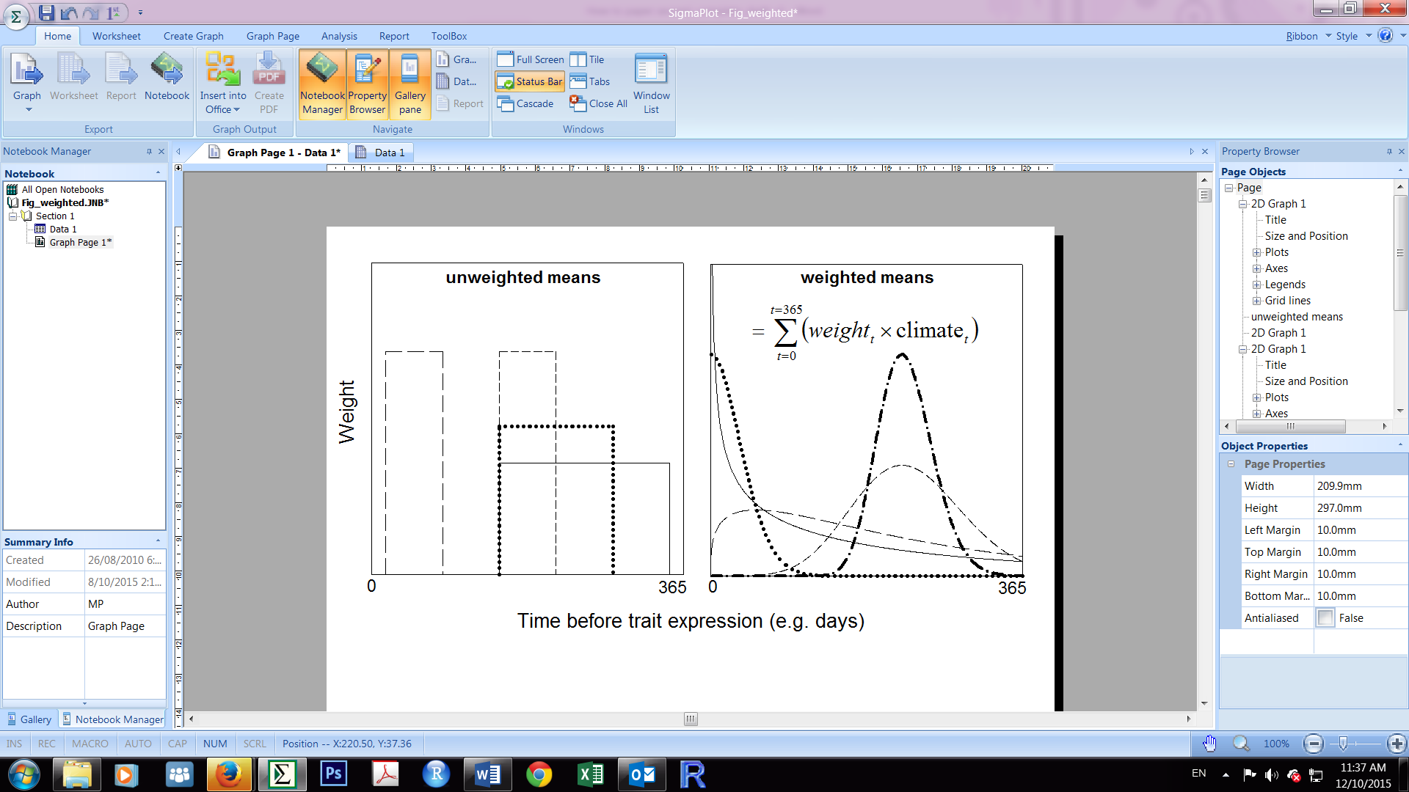

*climwin* allows for testing of weighted meansvia the function weightwin based on the methods described in van de Pol & Cockburn (2011). Since the weight function used to calculate the weighted mean needs to be estimated (it has a shape, location and width parameter) and can take on an infinite number of forms, weightwin uses different optimization methods than slidingwin to find the best window described by the weighted mean function. Nonetheless, the output from weightwinthat describes the best supported weather signal can be directly compared to the output from models fitted by the slidingwin function to investigate whether a weighted mean model is better supported by the data than, for example, a model with the aggregate statistic mean, as we will show in the next section:

We first run the weighted mean model using the weightwin function:

> weightoutput <- weightwin( baseline = lm(Laydate ~ 1, data = Biol),

+ xvar = list(Clim$Temp),

+ type = "absolute",

+ range = c(365, 0),

+ func = "lin",

+ refday = c(30, 6),

+ cinterval = "day",

+ cdate = Clim$Date, bdate = Biol$Date,

+ weightfunc = "W", par = c(3, 0.2, 0),

+ control = list(ndeps = c(0.01, 0.01, 0.01)),

+ method = "L-BFGS-B")

The weightwin function shares many of the arguments of the slidingwin function, but the stat argument is removed (as this is by default a weighted mean), and there are 4 new arguments included: weightfunc and par set the shape, scale and location parameters of the weightfunction (“W”=Weibull probability density function), while control and method influence the optimization algorithm (see the help function of function optim() from the *stats* package for details). Running the code produces the following plots:

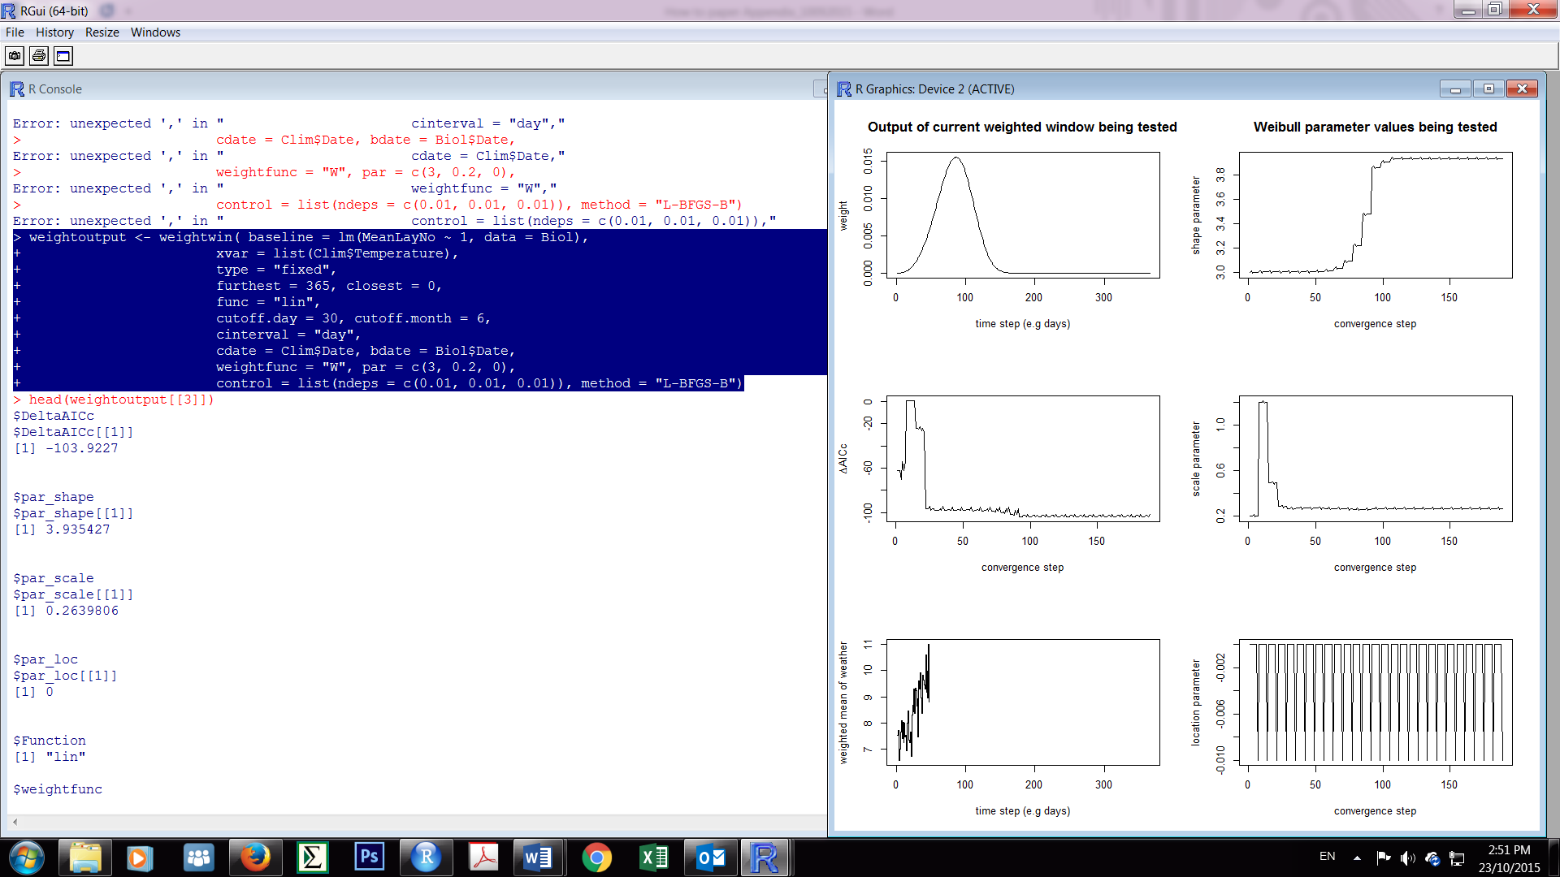

The top left plot shows the best weighted mean time window, which looks very similar to the mean temperature window from day 49-113. Interestingly, the ∆AICc of the weighed mean is more negative than that of the (unweighted) mean temperature model (∆AICc =-103.9 vs. ∆AICc =-96.8; this can be found using head(weightoutput[[3]])). Thus modeling the effect of temperature using a weighted mean is actually best supported by the data, which in our experience is typically the case: it usually performs at least as good as an unweighted mean. The five other plots show the convergence trajectories during the optimization routine for the ∆AICc, the value of the weighted mean temperature value, and the three (shape, scale and location) parameters of the weight function that are being optimized. We can look at the best model using summary(weightoutput[[1]]) and extract the best weighted mean for further analysis using Biol$signal<-weightoutput[[2]]$climate.

It should be noted that sometimes the outcome of the weightwin function can depend on the starting values set in the par argument, or on the step size of the optimization algorithm used (control argument). As the optimization routine can get stuck on a local optimum, it is advisable to try several starting values of the shape, scale and location parameter. The outcome of different runs using weightwin can be directly compared and the results that give the lowest ∆AICc is the best supported model. It should also be noted that different combinations of the values of the shape, scale and location parameters can give weight functions (see top left plot above) that look very similar, and thus it is not so much the actual values of these three parameters that are of biological interest, but the overall shape of the weight function is biologically of most interest. For example, in the plot above, the weight function suggests that a time window from roughly day 40-140 is most strongly supported with the peak of the weight (i.e. the days where weather most strongly influences variation in trait expression) being around day 90, and the importance of earlier and later days decaying gradually.

We can assess the likelihood that the observed signal is due to chance using randomization:

> randweight<-randwin(repeats = 100,

+ baseline = lm(Laydate ~ 1, data = Biol),

+ xvar = list(Clim$Temp),

+ type = "absolute",

+ range = c(365, 0),

+ func = "lin",

+ refday = c(30, 6),

+ cinterval = "day",

+ cdate = Clim$Date, bdate = Biol$Date,

+ weightfunc = "W", par = c(3, 0.2, 0),

+ control = list(ndeps = c(0.01, 0.01, 0.01)),

+ method = "L-BFGS-B", window="weighted")

We can now then asses the P∆AICc values

> pvalue(datasetrand = randweight[[1]], dataset = weightoutput[[3]], metric="AIC", sample.size=47)

≤0.01

It should be noted that PC is not available for weighted windows, only P∆AICc.. However, this is not a limitation, as the use of P∆AICc is preferable over PC , and because weighted windows are much faster to run than sliding windows, one can easily run many randomizations to calculate P∆AICc precisely.

**What level of variation does the weather signal explain?**

In the Chaffinch example above we had one (aggregate) measurement per year, and as such our weather signal could only explain variation among years. However, our data may often contain replication and structuring. For example, one could have collected time-series of mean annual laying dates of Chaffinches for many populations (note that weather data from different weather stations can be included using the argument spatial, see documentation of function slidingwin or weightwin). In such a situation a weather signal can potentially explain both the among-year variation in Chaffinch laying dates within each site, but potentially also the among-site variation in laying dates if sites also vary in their mean weather conditions. This scenarios is shown in the figure below for a case where we measured three sites (A,B,C) over different years (1-15).

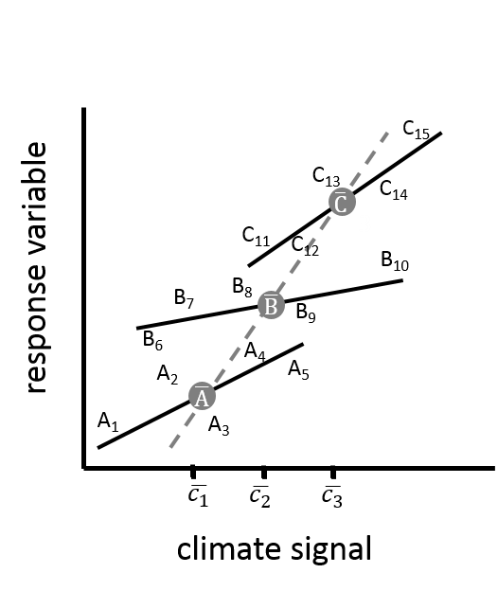

Biologically the within-site slope (solid line) and among-site slope may not be of the same magnitude. For example, frog spawning dates in the UK showed much stronger temperature sensitivity among British populations than did the average temperature-sensitivities within-populations over time (Phillimore *et al.* 2010). If one has variation in weather at two levels, here within and among sites, one level of variation might be of stronger interest than the other. For example, for future projections of climate change the among-year relationship with weather within sites might be more relevant than any among-site relationship.

Methods exists that can separate these two levels of aggregation. *climwin* uses a technique called within-group centering (van de Pol & Wright 2009). By setting the argument centre in slidingwin to siteID (centre=list(Biol$siteID,”both”), slidingwin will instead of calculating one weather signal (e.g. maximum temperature), calculate two weather variables that separate the variation in the weather signal into a within- and between-site component, specifically (i) the maximum temperature during the window of interest averaged across all years for that site (i.e. the average weather signal of that site) and (ii) the difference between the avg. weather signal and the original weather signal (i.e. the annual within-site deviation of the weather signal). More formally instead of running the model:

**

slidingwinuses the following model if the centre argument is used:

**

Where *xij* is the weather signal in site *j* in year *i* (e.g. the max temperature from day 49 to day 113) and $\overline{x_{j}}$ the weather signal averaged across all years *i* for site *j*, andis the random site effect and the residual error term. Because we now separated the weather signal into a within-and between-site component, the two slope terms**and ** now separately estimate the within-site and between-site weather sensitivities, respectively (see van de Pol & Wright 2009 for details). And slidingwin will output these two estimates accordingly in the summary of the Bestmodel object. The next section on relative time windows will show another example where the weather signal can explain variation at two levels, specifically a situation where we have measured multiple individuals in the same site over many years, and the weather signal may explain both the within-year variation among individuals and the between-year variation. This next example will also include some R code to illustrate the usage and interpretation of the argument centre.

**Relative time windows**

In situations where there is relatively little variation among years in the timing of the biological response, as seen in Chaffinch laying date, a focus on absolute time windows is often most appropriate. Where this variation is much greater, considering relative time windows is often necessary. In the following example we explore relative time windows by focusing on the body size (a composite measure of tarsus, wing and head-bill length standardized into a z-score, such that a mean size bird has a value of zero and the variation in size equals one) of red-winged fairy wren chicks (*Malurus elegans*). In each breeding season (running from October to January in the Australian summer) chicks were measured in the nest a week after hatching. In total there are just over 1000 measurement over 7 breeding seasons (2008-2014). Since there is substantial variation in the timing of nesting, some chicks hatch (and are measured) early in the breeding season (October) and some late (January). As it gets much drier and hotter during the breeding season, individuals from the same cohort will experience very different climatic conditions.

We investigate how weather affects variation in offspring body mass within a year (note that this contrasts to the question of explaining between-year variation in the Chaffinch example). Our ultimate goal is to quantify how the number of helpers at the nest (fairy wrens are cooperative breeders in which offspring stay at home to help rear the next brood) affects offspring size. However, we suspect that weather likely also affects growth, and we would like to account for such weather sensitivity in order to better estimate the helper effect.

In this system, absolute windows are biologically unrealistic as they imply that all individuals are affected by weather at the same point in time, despite individuals varying widely (several months) in their timing of expression (i.e. hatching). Relative time windows will be more appropriate because (i) there is substantial among-individual variation in the timing of trait expression (here body size) and (ii) short-lag signals are expected (e.g. the weather during the week between hatching and measurement might affect the growth and thereby body size of offspring). Specifically, we hypothesize that warm temperatures will be good for growth as chicks spend less energy on thermoregulation. Alternatively, we predict that high rainfall will be detrimental for growth as this can prevent the parents from foraging.

We designed a baseline model using results from a previous study (Brouwer *et al.* 2014): chick body size was found to be a function of the number of female helpers that feed the offspring. Furthermore, since we measured the body size of chicks from the same nest, we included NestID as a random effect (intercept) to account for such non-independency. For illustration purposes we only consider the aggregate statistics mean and linear response functions. Furthermore, as we are mainly interested in short-lag signals (long-lag signals might be better captured using absolute windows), we only consider relative windows going back a maximum of 100 days (furthest=100):

> data(Size)

> data(SizeClimate)

> library(lme4)

> output_rel <-slidingwin(baseline=lmer(Size~Helpers+(1|NestID),

+ data=Size, REML=FALSE),

+ xvar = list(Temp = SizeClimate$Temperature,

+ Rain = SizeClimate $Rain),

+ type = "relative",

+ range = c(100, 0),

+ stat = c("mean"),

+ func = c("lin"),

+ refday = c(31, 1),

+ cinterval = "day",

+ cdate = SizeClimate$Date, bdate = Size$Date)

> output_rel$combos

climate type stat func beta_lin DeltaAICc close open

1 Temp relative mean lin 0.0885 -22.43 0 6

2 Rain relative mean lin -0.172 -24.46 0 22

Our results show that mean temperature from day 0-6 before measuring chick mass (typically done at day 8 after hatching) may have a potentially positive effect on offspring size (effect size is 0.0885SD/°C). Additionally, mean rainfall 0-22 days before chick measurement appears to have a negative effect on offspring size (effect size is -0.172 SD/mm rain), which seems to be particularly strong.

> plotdelta (output_rel[[1]]$Dataset)

> plotdelta (output_rel[[2]]$Dataset)

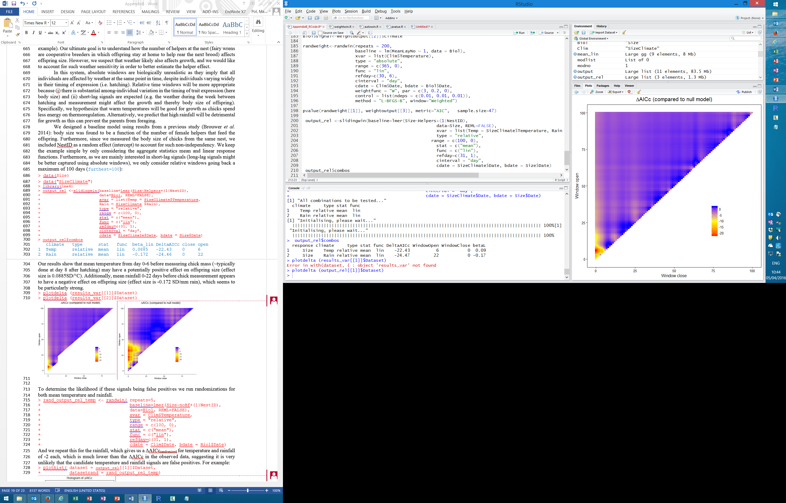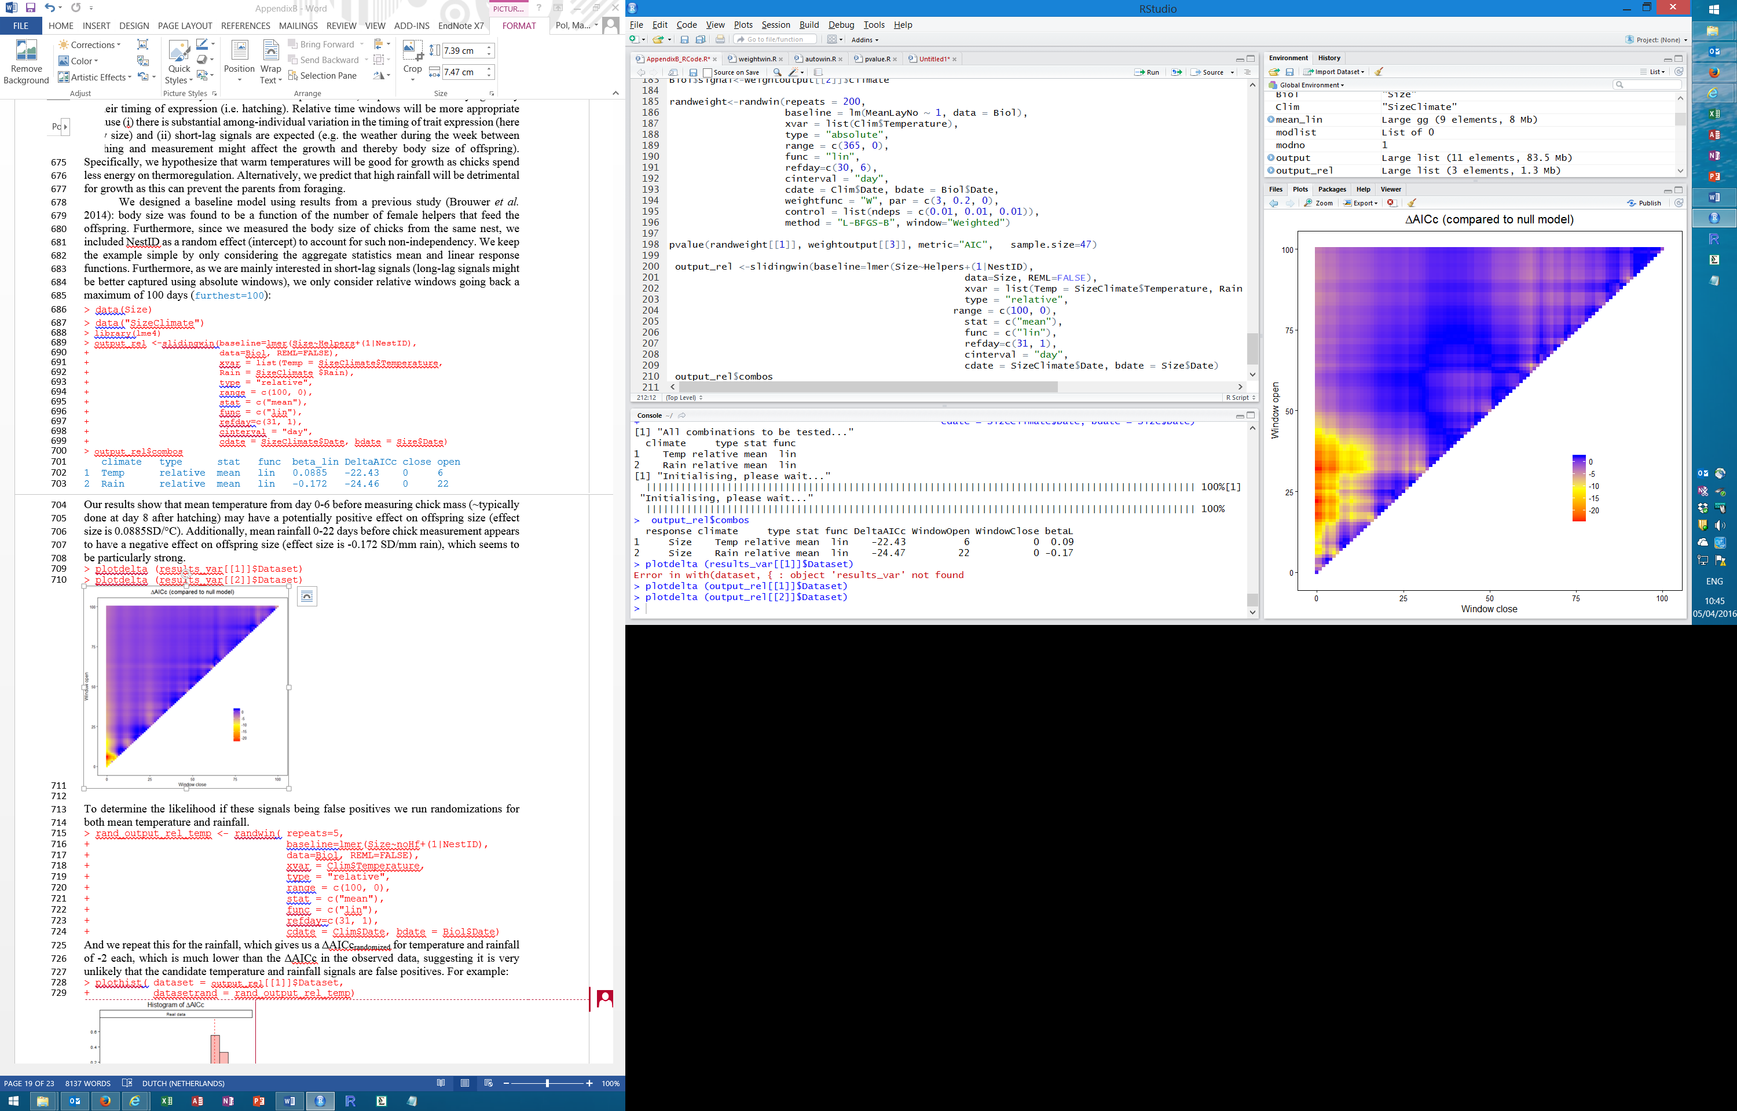

To determine the likelihood if these signals being false positives we run randomizations for both mean temperature and rainfall.

> rand_output_rel <- randwin( repeats=5,

+ baseline=lmer(Size~Helpers+(1|NestID),

+ data=Size, REML=FALSE),

+ xvar = list(Temp = SizeClimate$Temperature,

+ Rain = SizeClimate $Rain),

+ type = "relative",

+ range = c(100, 0),

+ stat = c("mean"),

+ func = c("lin"),

+ refday=c(31, 1),

+ cinterval = "day",

+ cdate = SizeClimate$Date, bdate = Size$Date,

+ window="sliding")

> pvalue(datasetrand = rand_output_rel[[1]], dataset = output_rel[[1]]$Dataset, metric="C", sample.size=1003)

0.0002

> pvalue(datasetrand = rand_output_rel[[2]], dataset = output_rel[[2]]$Dataset, metric="C", sample.size=1003)

0.0178

This shows that it is very unlikely that the candidate temperature and rainfall signals are false positives.

In this dataset, relative time windows can explain both the within- and between-year variation in offspring size. Note that if we would have used absolute time windows then all offspring would have had the same weather window and (in the absence of micro-climatic data at the nest level) this would mean that the weather signals would not vary between individuals from the same year, and could thus only explain the between year variation in offspring size. As we are primarily interested in the within-year relationship between weather and offspring size, we can apply within-group centering to separate these two effects using the centre argument:

> output_rel_centre <-slidingwin(centre=list(Size$Cohort, "both"),

+ baseline=lmer(Size~Helpers+(1|NestID),

+ data=Size, REML=FALSE),

+ xvar = list(Temp = SizeClimate$Temperature,

+ Rain = SizeClimate$Rain),

+ type = "relative",

+ range = c(100, 0),

+ stat = c("mean"),

+ func = c("lin"),

+ refday = c(31, 1),

+ cinterval = "day",

+ cdate = SizeClimate$Date, bdate = Size$Date)

> summary(output_rel_centre[[2]]$BestModel)

Linear mixed model fit by maximum likelihood ['lmerMod']

Formula: yvar ~ Helpers + (1 | NestID) + wgdev + wgmean

Data: Size

AIC BIC logLik deviance df.resid

2266.2 2295.7 -1127.1 2254.2 997

Scaled residuals:

Min 1Q Median 3Q Max

-4.5828 -0.3984 0.0452 0.3876 6.6033

Random effects:

Groups Name Variance Std.Dev.

NestID (Intercept) 0.7186 0.8477

Residual 0.2132 0.4617

Number of obs: 1003, groups: NestID, 461

Fixed effects:

Estimate Std. Error t value

(Intercept) -0.22586 0.21126 -1.069

Helpers 0.19529 0.05532 3.530

wgdev -0.14704 0.04208 -3.494

wgmean 0.02823 0.05688 0.496

This output shows the effect size for mean rainfall separated into a within-year effects (the wgdev parameter above) and a between-year effect (wgmean). We can see that the rainfall effect is mainly a within-year effect. The ∆AICc of the rainfall model also improved a lot due to the within-group centering, and the time window is somewhat shorter than in the best model without centering (5-10 instead of 0-22). Below we summarize both variables:

climate type stat func beta_wgdev beta_wgmean DeltaAICc close open

1 Temp relative mean lin 0.114 -0.167 -18.45 0 6

2 Rain relative mean lin -0.147 0.0282 -33.33 5 10

Another complexity with explaining within-year variation of traits that are expressed at different times of the year is that traits may show seasonal patterns independent of weather. For example, several avian reproductive parameters show declines over the season (e.g. Verhulst, van Balen & Tinbergen 1995). As most weather variables also show seasonal trends, it can be useful to de-trend weather variables in such situations to assure that the de-trended weather variable is explaining within-year variation for reasons beyond any seasonal trend.

For the final model selection (step 4) we extract these two candidate signals: the mean temperature from day 0-6 and the mean rainfall from day 5-10. We look at the correlation between the two signals.

> Size$TempSignal<- output_rel_centre[[1]]$BestModelData$wgdev

> Size$RainSignal<- output_rel_centre[[2]]$BestModelData$wgdev

> cor(Size$TempSignal, Size$RainSignal)

[1] -0.8281765

Unsurprisingly the two weather parameters are strongly negatively correlated. To determine the final model we add both candidate signals to the baseline model:

> model <-lmer(Size~1+TempSignal+RainSignal+Helpers+(1|NestID), data= Size, REML=FALSE)

> summary(model)

Linear mixed model fit by maximum likelihood ['lmerMod']

Formula: Size ~ 1 + TempSignal + RainSignal + Helpers + (1 | NestID)

Data: Size

AIC BIC logLik deviance df.resid

2266.2 2295.7 -1127.1 2254.2 997

Scaled residuals:

Min 1Q Median 3Q Max

-4.5809 -0.3978 0.0454 0.3924 6.6049

Random effects:

Groups Name Variance Std.Dev.

NestID (Intercept) 0.7185 0.8477

Residual 0.2132 0.4617

Number of obs: 1003, groups: NestID, 461

Fixed effects:

Estimate Std. Error t value

(Intercept) -0.12575 0.05189 -2.423

TempSignal 0.03020 0.06328 0.477

RainSignal -0.11843 0.07393 -1.602

Helpers 0.19488 0.05526 3.526

Correlation of Fixed Effects:

(Intr) TmpSgn RnSgnl

TempSignal -0.062

RainSignal -0.011 0.822

Helpers -0.575 0.085 0.046

This model suggest that the RainSignal is strongest and that there is no effect of the TempSignal after accounting for the RainSignal effect. The final model may thus only include the RainSignal effect:

> finalmodel <- lmer(Size~1+RainSignal+Helpers+(1|NestID), data=Size, REML=FALSE)

> summary(finalmodel)

Linear mixed model fit by maximum likelihood ['lmerMod']

Formula: Size ~ 1 + RainSignal + Helpers + (1 | NestID)

Data: Biol

AIC BIC logLik deviance df.resid

2264.4 2289.0 -1127.2 2254.4 998

Scaled residuals:

Min 1Q Median 3Q Max

-4.5832 -0.3983 0.0448 0.3892 6.6028

Random effects:

Groups Name Variance Std.Dev.

NestID (Intercept) 0.7190 0.8479

Residual 0.2132 0.4617

Number of obs: 1003, groups: NestID, 461

Fixed effects:

Estimate Std. Error t value

(Intercept) -0.12421 0.05180 -2.398

RainSignal -0.14744 0.04209 -3.503

Helpers 0.19264 0.05508 3.498

This model shows that there is a strong negative effect of rainfall (-0.147 SD/mm) on offspring size in the 5-10 days before measurement. However, due to the very high collinearity with temperature we should also consider the alternative interpretation that this effect may instead be driven by a negative effect of temperature.

One should not focus too much on the exact window of 5-10 days, as neighbouring windows such as 0-6 or 0-22 are very strongly correlated with the best window, and there thus is quite some uncertainty around the exact open and closing day of the window. However, fortunately this uncertainty does not affect the values of the weather signals and estimates of the weather sensitivities much:

> plotbetas(output_rel_centre[[2]]$Dataset)

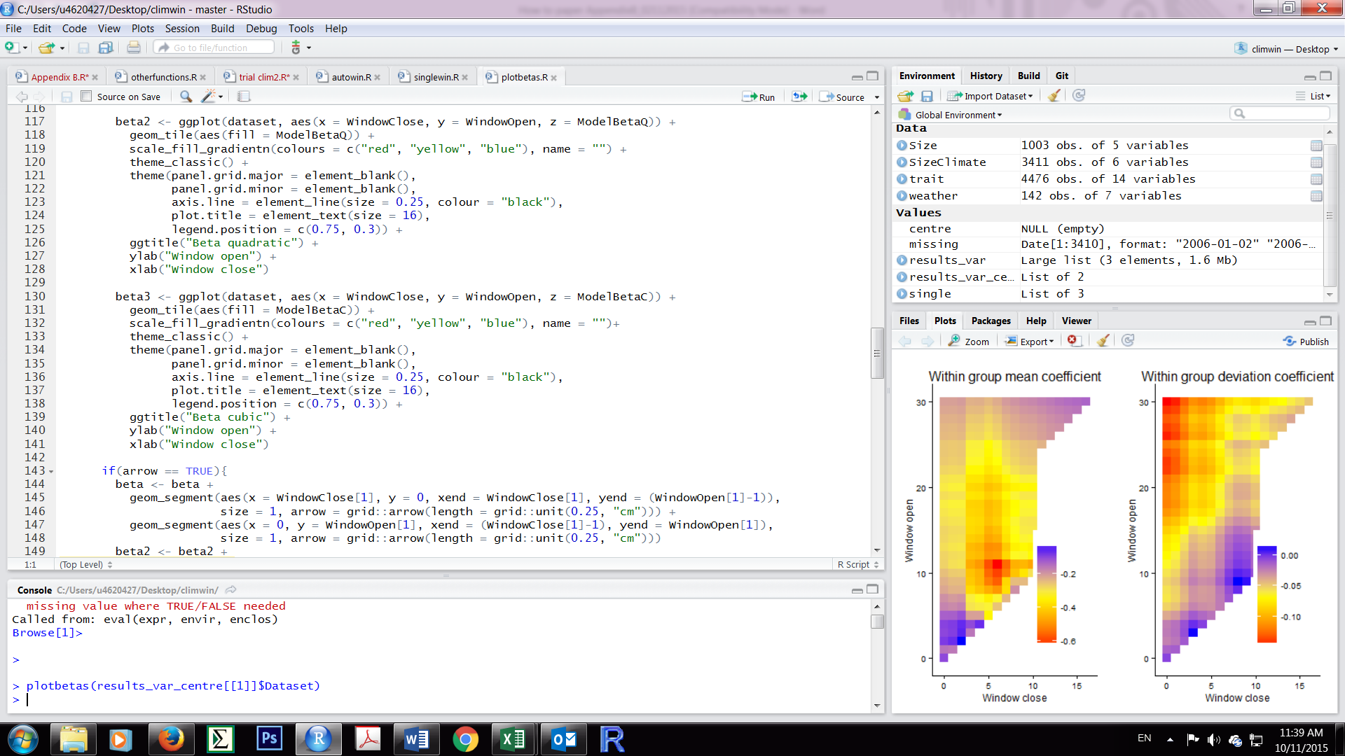

**References**

Brouwer, L., van de Pol, M. & Cockburn, A. (2014) The role of social environment on parental care: offspring benefit more from the presence of female than male helpers. *Journal of animal ecology*, **83**, 491–503.

Baillie, S.R., Marchant, J.H., Leech, D.I., Massimino, D., Sullivan, M.J.P., Eglington, S.M., Barimore, C., Dadam, D., Downie, I.S., Harris, S.J., Kew, A.J., Newson, S.E., Noble, D.G., Risely, K. & Robinson, R.A. (2014) BirdTrends 2014: trends in numbers, breeding success and survival for UK breeding birds. BTO Research Report 662. British Trust for Ornithology, Thetford.

Burnham, K.P. & Anderson, D.R. (2002) *Model Selection and Multimodel Inference: A Practical Information-Theoretic Approach*. Springer Science & Business Media.

Burnham, K.P., Anderson, D.R. & Huyvaert, K.P. (2011) AIC model selection and multimodel inference in behavioral ecology: some background, observations, and comparisons. *Behavioral Ecology and Sociobiology*, **65**, 23–35.

Crick, H.Q.P. & Sparks, T.H. (1999) Climate change related to egg-laying trends. *Nature*, **399**, 423–424.

Gienapp, P., Hemerik, L. & Visser, M.E. (2005) A new statistical tool to predict phenology under climate change scenarios. *Global Change Biology*, **11**, 600–606.

Kruuk, L.E., Osmond, H.L. & Cockburn, A. (2015) Contrasting effects of climate on juvenile body size in a Southern Hemisphere passerine bird. *Global change biology*.

Parker, D.E., Legg, T.P. & Folland, C.K. (1992) A new daily central England temperature series, 1772–1991. *International Journal of Climatology*, **12**, 317–342.

Phillimore, A.B., Hadfield, J.D., Jones, O.R. & Smithers, R.J. (2010) Differences in spawning date between populations of common frog reveal local adaptation. *Proceedings of the National Academy of Sciences*, **107**, 8292–8297.

van de Pol, M. & Cockburn, A. (2011) Identifying the critical climatic time-window for trait expression. *American Naturalist*, **177**, 698-707.

van de Pol, M., Osmond, H.L. & Cockburn, A. (2012) Fluctuations in population composition dampen the impact of phenotypic plasticity on trait dynamics in superb fairy-wrens. *Journal of Animal Ecology*, **81**, 411-421.

van de Pol, M. & Wright, J. (2009) A simple method for distinguishing within- versus between-subject effects using mixed models. *Animal Behaviour*, **77**, 753–758.

Schaper, S.V., Dawson, A., Sharp, P.J., Gienapp, P., Caro, Samuel P. & Visser, M.E. (2012) Increasing Temperature, Not Mean Temperature, Is a Cue for Avian Timing of Reproduction. *The American Naturalist*, **179**, E55–E69.

Verhulst, S., van Balen, J.H. & Tinbergen, J.M. (1995) Seasonal decline in reproductive success of the great tit: Variation in time or quality? *Ecology*, **76**, 2392–2403.